|  |
| --- |
|  |
| Capstone Project Document |

**Vietnamese Studying System for Japanese**

Report #6 – User Guide

**- Ha Noi, 08/2016 -**

# SIGNATURE PAGE

AUTHOR: Phạm ĐứcThắng 05/08/2016

Team member

REVIEWERS: Nguyễn Ngọc Minh --/08/2016

Project manager

APPROVAL: Nguyễn Văn Sang --/Aug/2016

Supervisor

**Record of change**

*A - Added M - Modified D – Deleted

|  |  |  |  |  |  |
| --- | --- | --- | --- | --- | --- |
| Effective Date | Changed Item | A,M,D | Change Description | Reason for Change | Rev. Number |
| 05/Aug/2016 | User-Guide | A | Add new |  | 1.0 |
| 15/Aug/2016 | User-Guide | M | Modify User Guide |  | 1.1 |
| 16/Aug/2016 | User-Guide | M | Modify User Guide |  | 1.2 |
| 18/Aug/2016 | User-Guide | M | Modify User Guide |  | 1.3 |
|  |  |  |  |  |  |

Table of Contents

SIGNATURE PAGE 0

1 USER GUIDE 1

1.1 Overview 1

1.2 Details guidelines 1

# 1 USER GUIDE

## Overview

This user's manual has been developed to help users better understand the requirements that may apply to use this website by providing them simple step by step tutorials. This manual is intended to help make website's functions more accessible and their associated requirements more understandable to users.

## Details guidelines

### Homepage

The first page which user will see is the homepage. From this page the user can go to every page they want.

Open browser and enter to the address bar:

http://localhost:3003/#/home

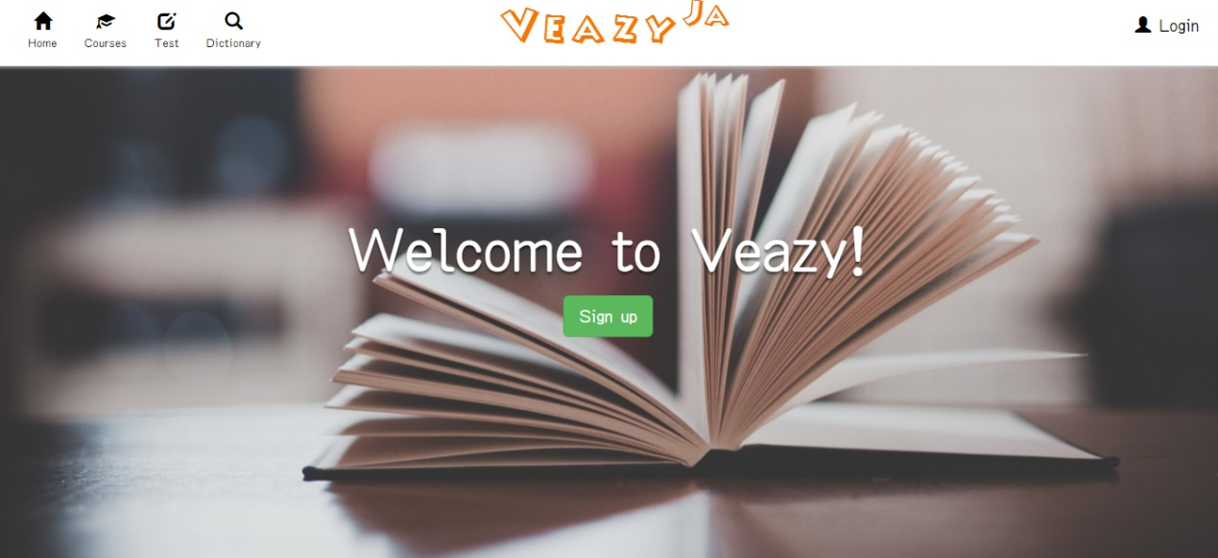

### How to Login

To login account on website, the users do the steps below:

Step 1: Click on “Login” hyperlink in homepage

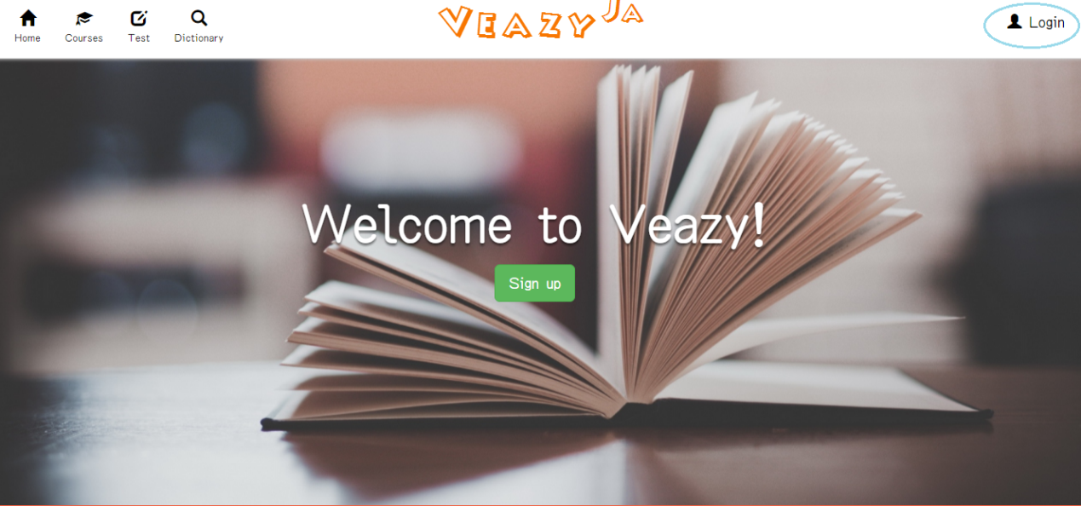

Step 2: User needs input username and password

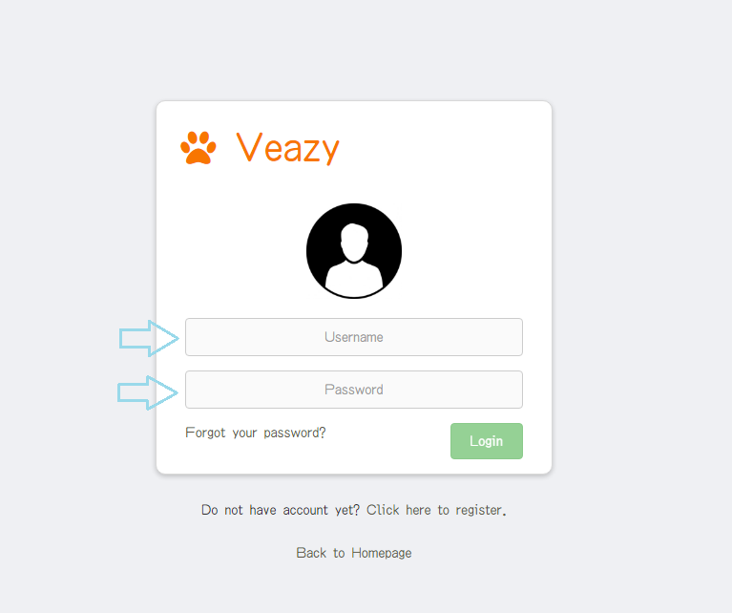

Step 3: Click on “Login” button

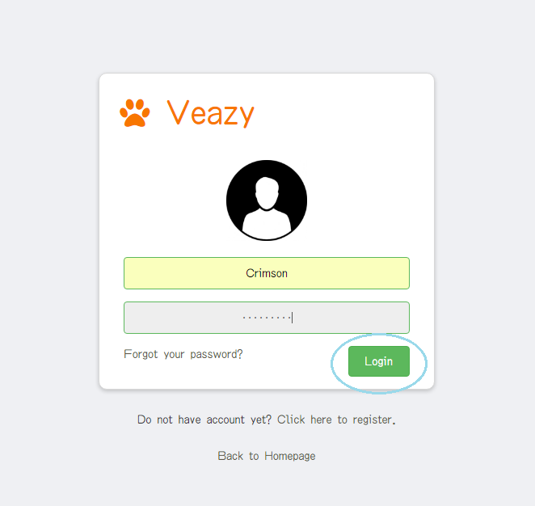

Step 4: System redirects to homepage if user login to member account successfully.

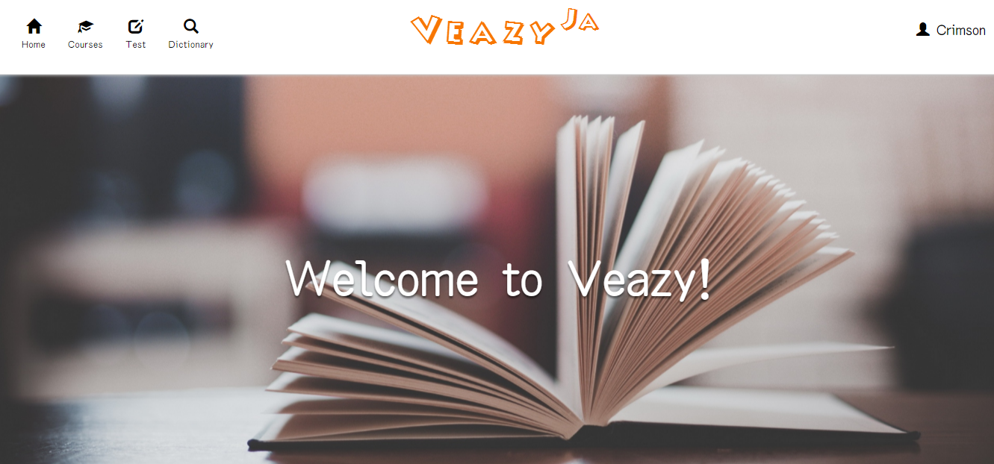

System redirects to editor dashboard if user login to editor account successfully.

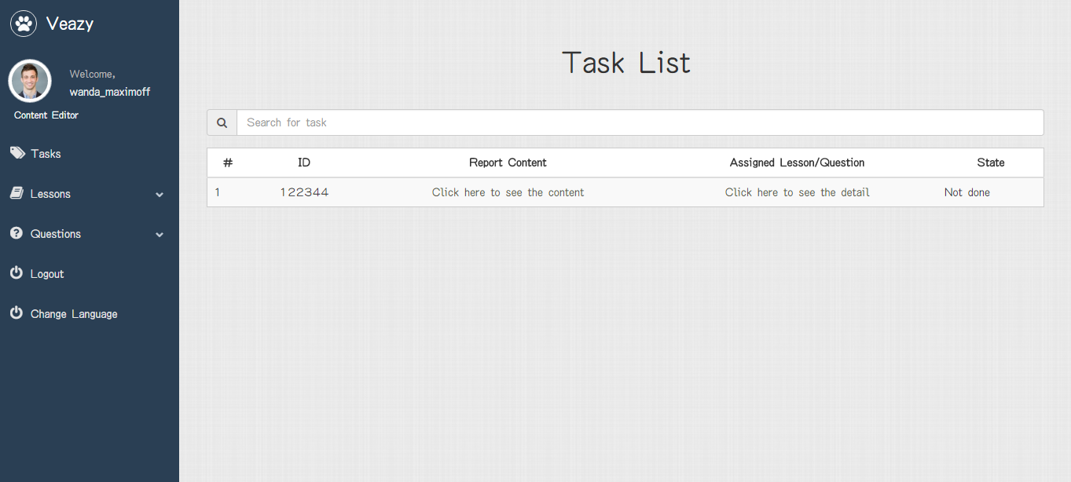

System redirects to admin dashboard if user login to admin account successfully.

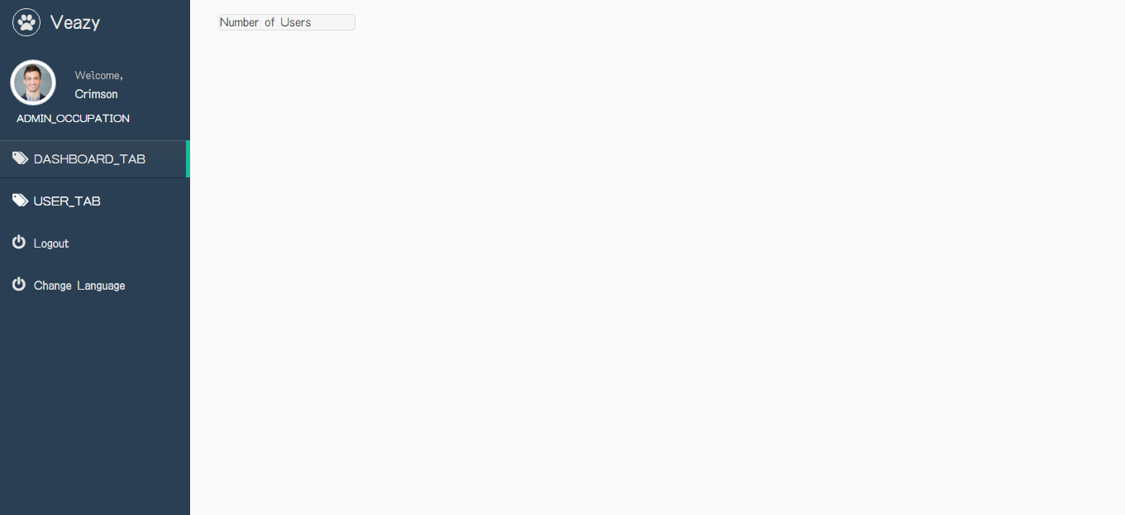

### How to Register

To register account on website, users do the steps below:

Step 1: Click on “Sign up” button in homepage or click “Click here to register” hyperlink in “Login” page

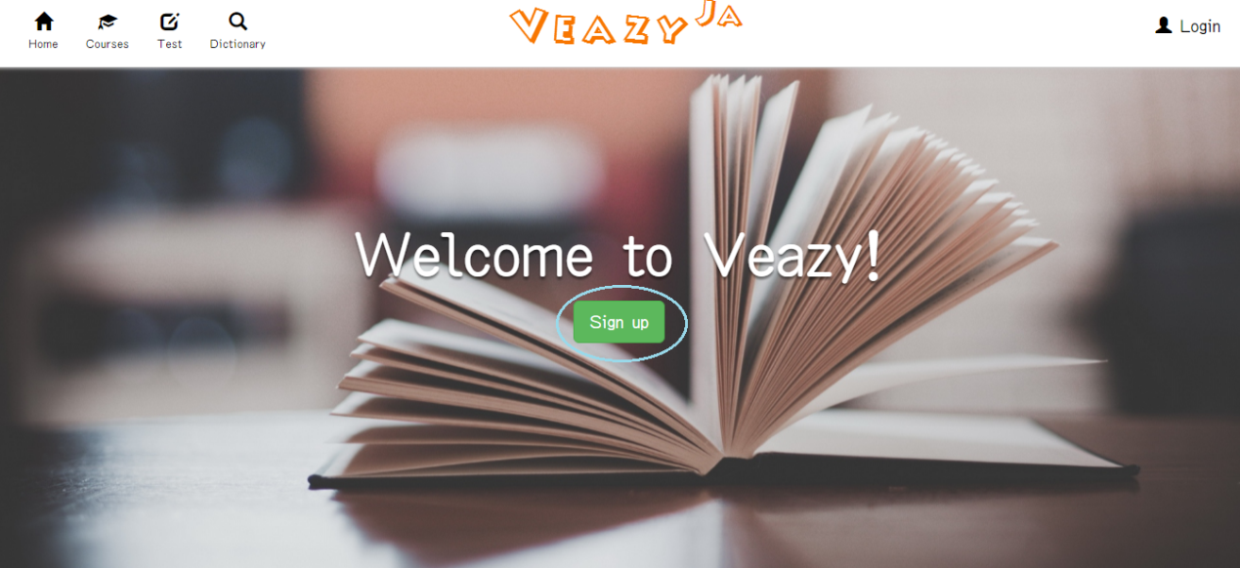

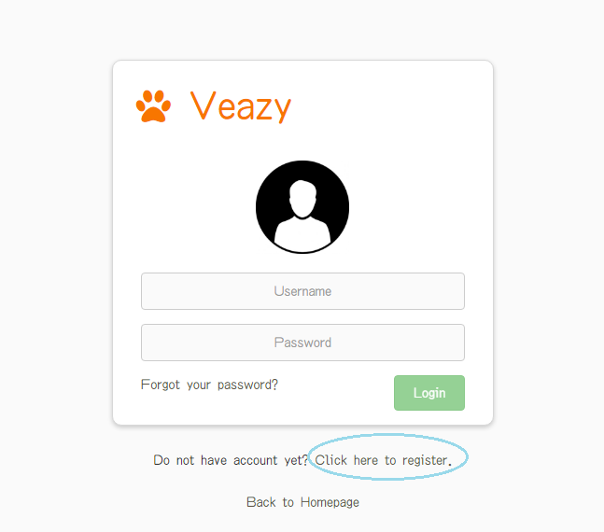

Step 2: System redirects to “Register” page

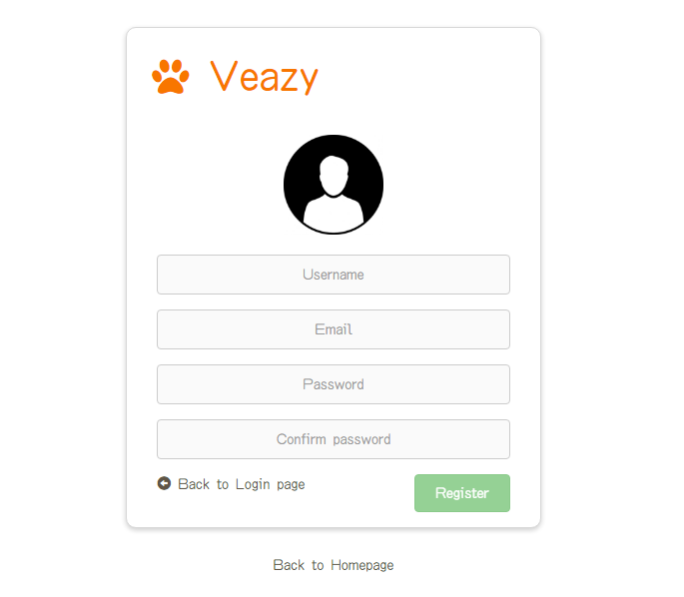

Step 3: User fill in user information into the textbox

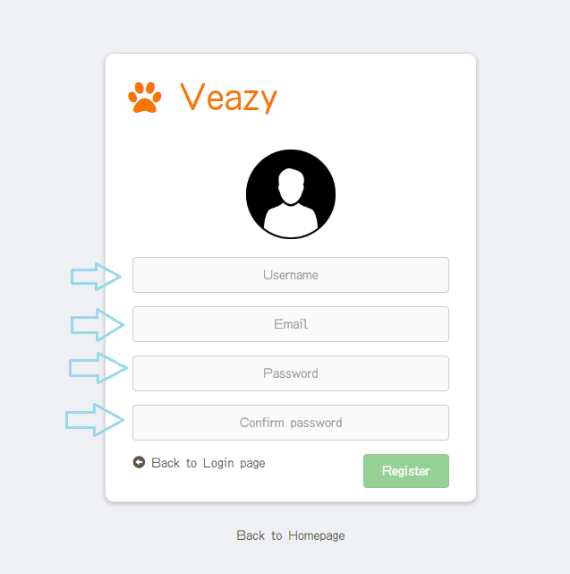

Step 4: Click “Register” button

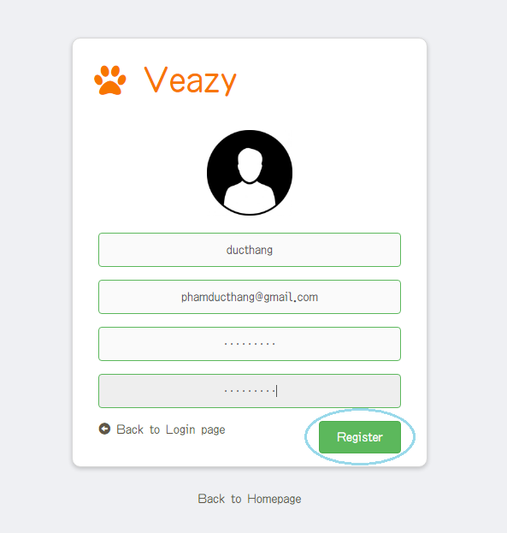

Step 5: System redirects to “Home” page

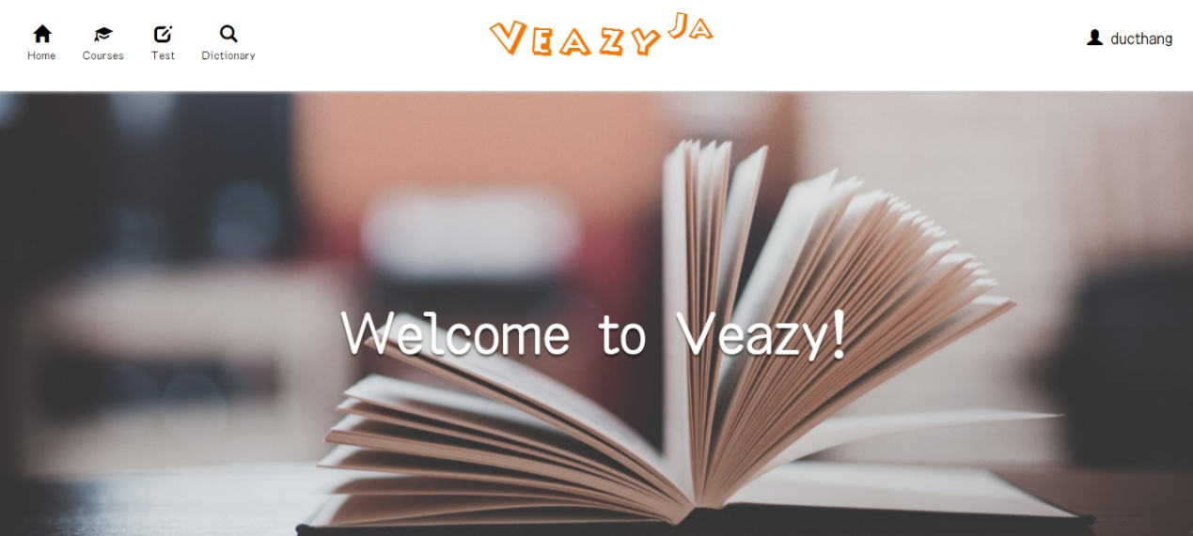

### How to Forgot Your Password

To reset password on website, the users do the steps below:

Step 1: User click on “Forgot your password?” hyperlink in “Login” page

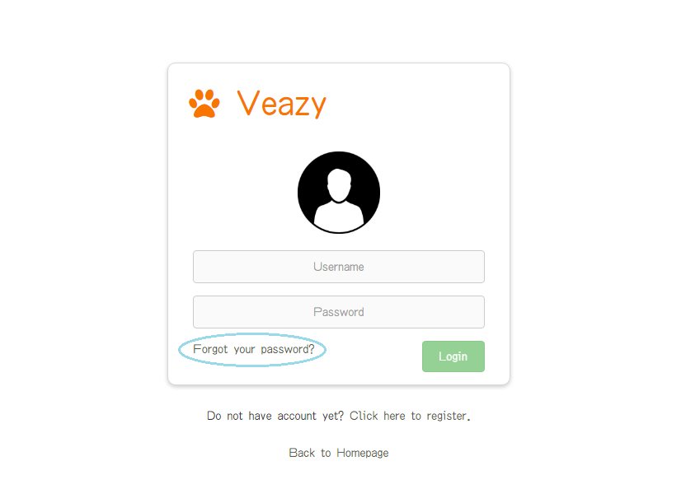

### How to Change Language

To change language on website, the users do the steps below:

Step 1: User clicks on “Veazy” logo at the top of menu in homepage

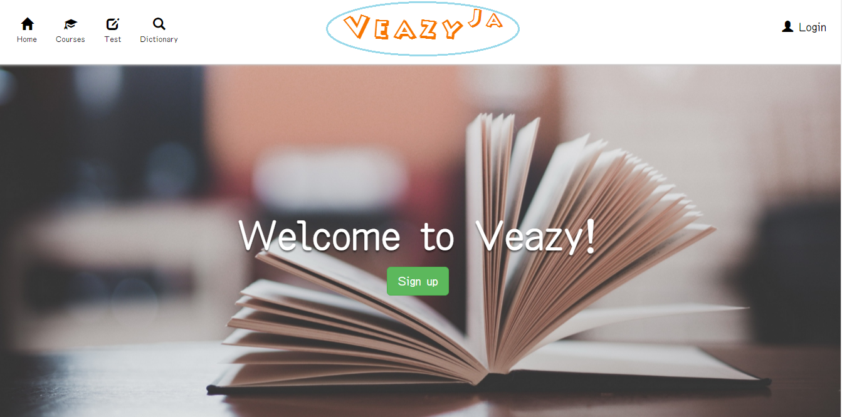

Step 2: System changed language

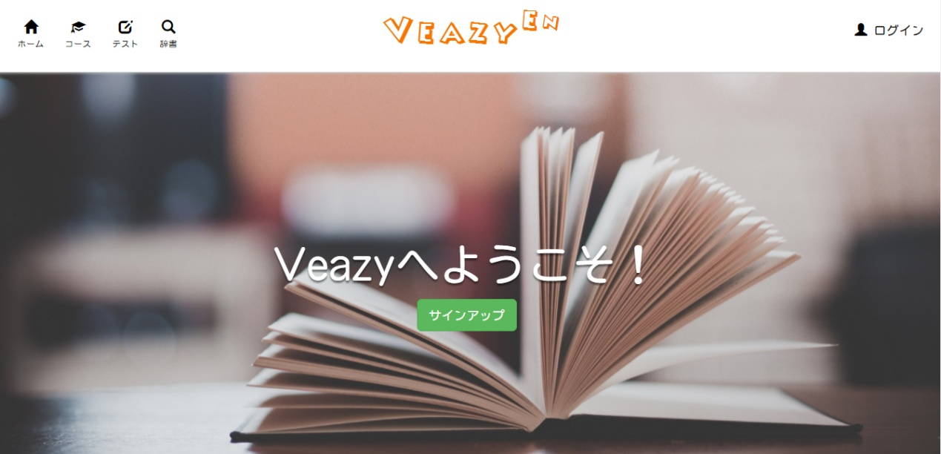

### Dictionary

### How to Learn Courses

#### Select Course

To select courses on website, the users do the steps below:

Step 1: User clicks on “Courses” hyperlink at the top menu in homepage

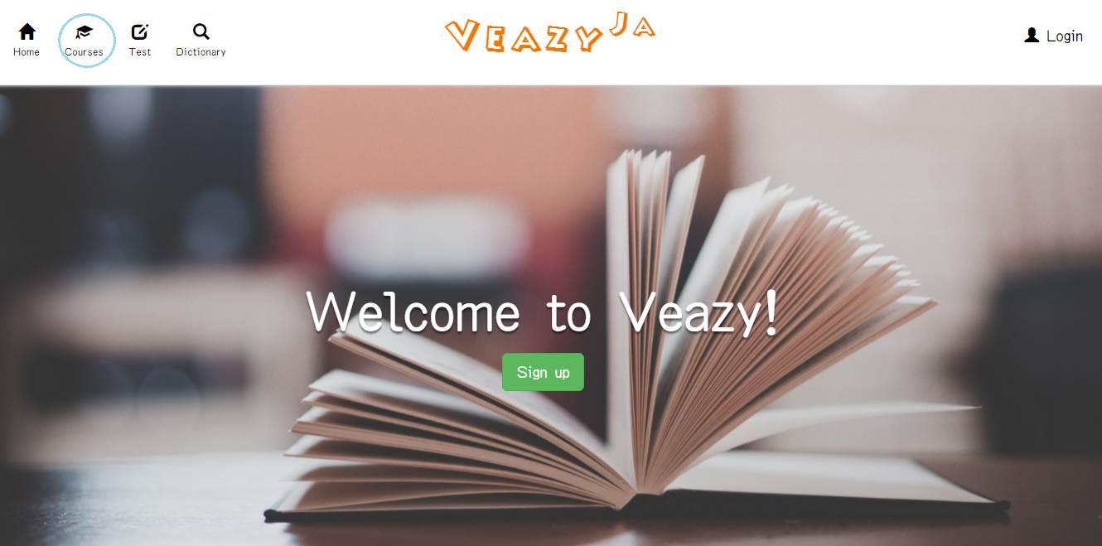

Step 2: User clicks on level hyperlink in dropdown list

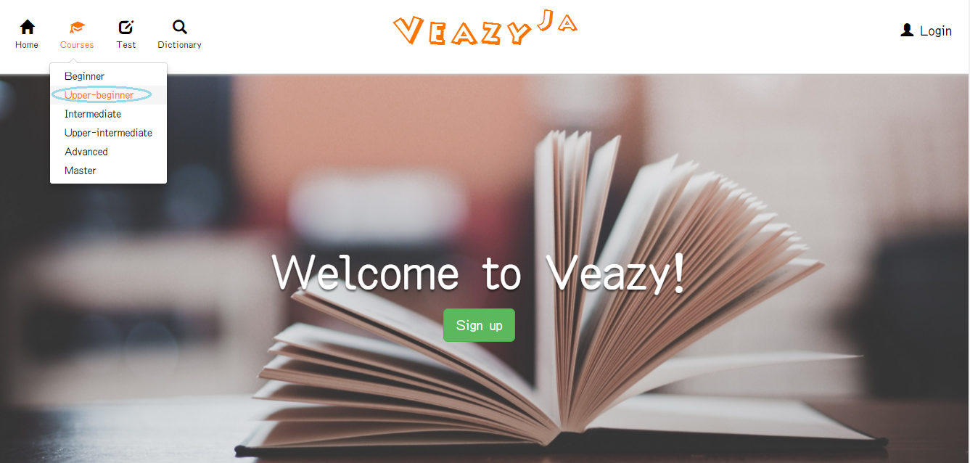

Step 3: System will redirects to “Courses” page

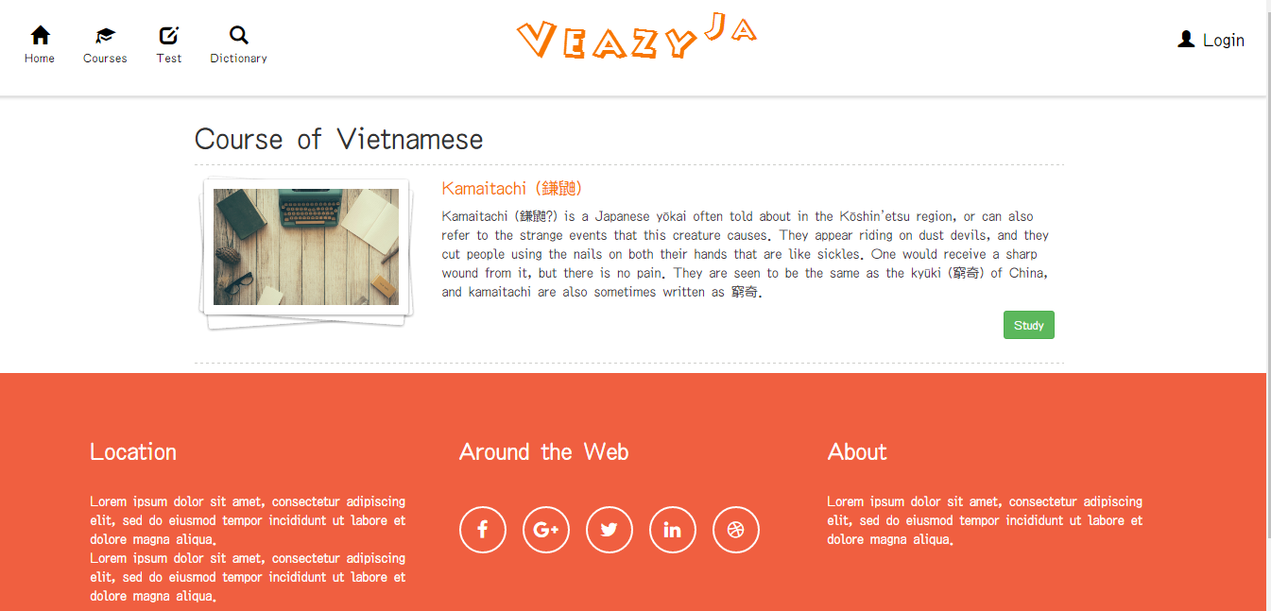

#### Start Study Lesson

To study lesson on website, the users do the steps below:

Step 1: User clicks on “Study” button in courses page

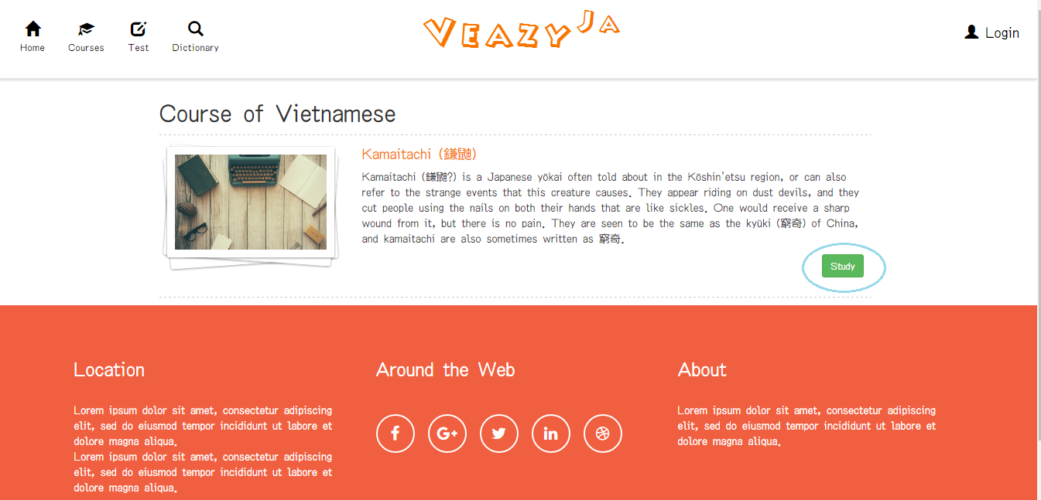

Step 2: System redirects to “Lesson” page

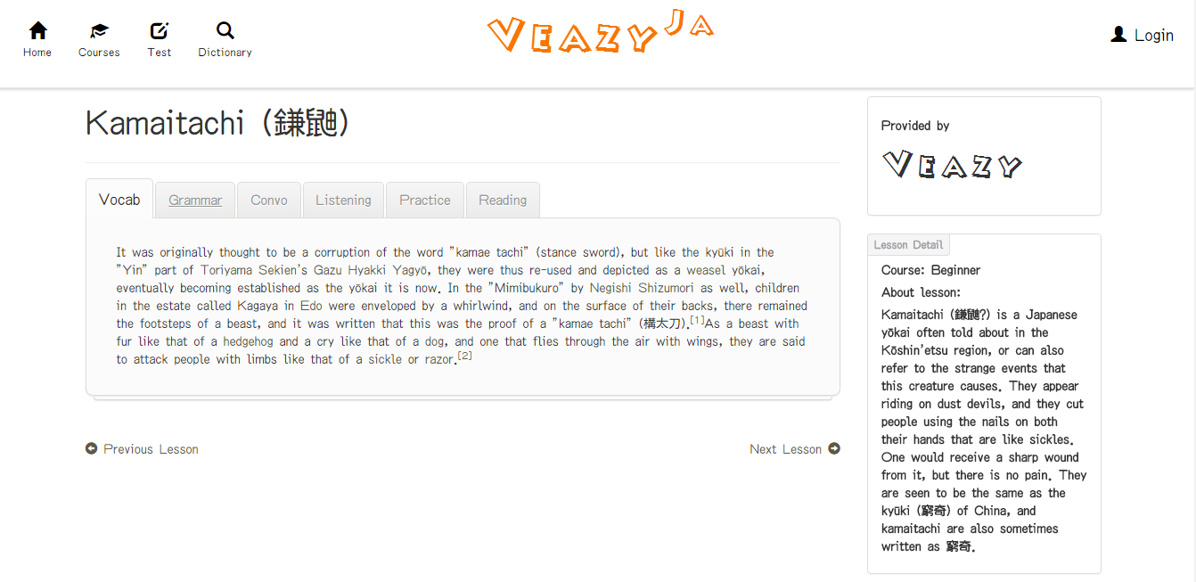

#### Learn Vocabulary

To learn vocabulary on website, the users do the steps below:

Step 1: User clicks “Vocab” link in “Lessons” page

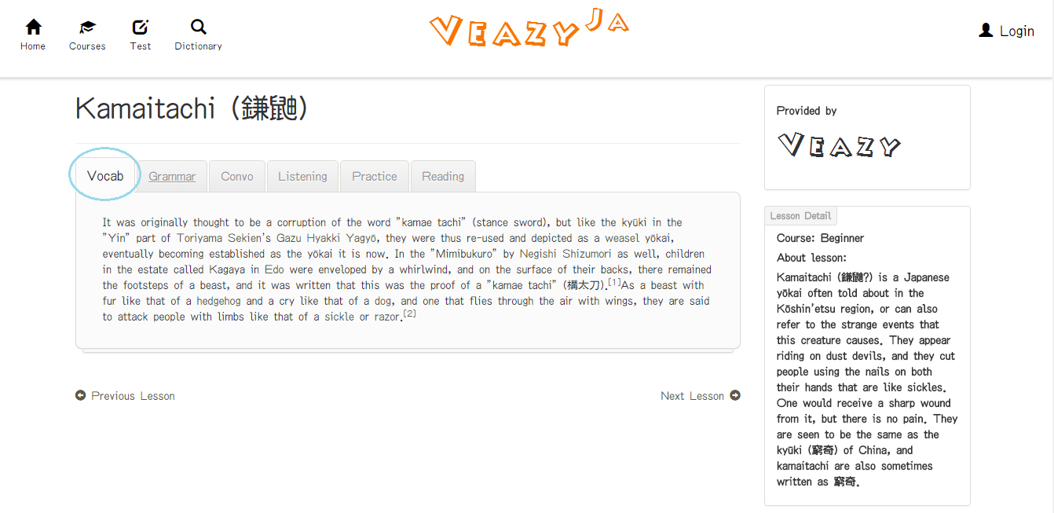

#### Learn Grammar

To learn grammar on website, the users do the steps below:

Step 1: User clicks “Grammar” link in “Lessons” page

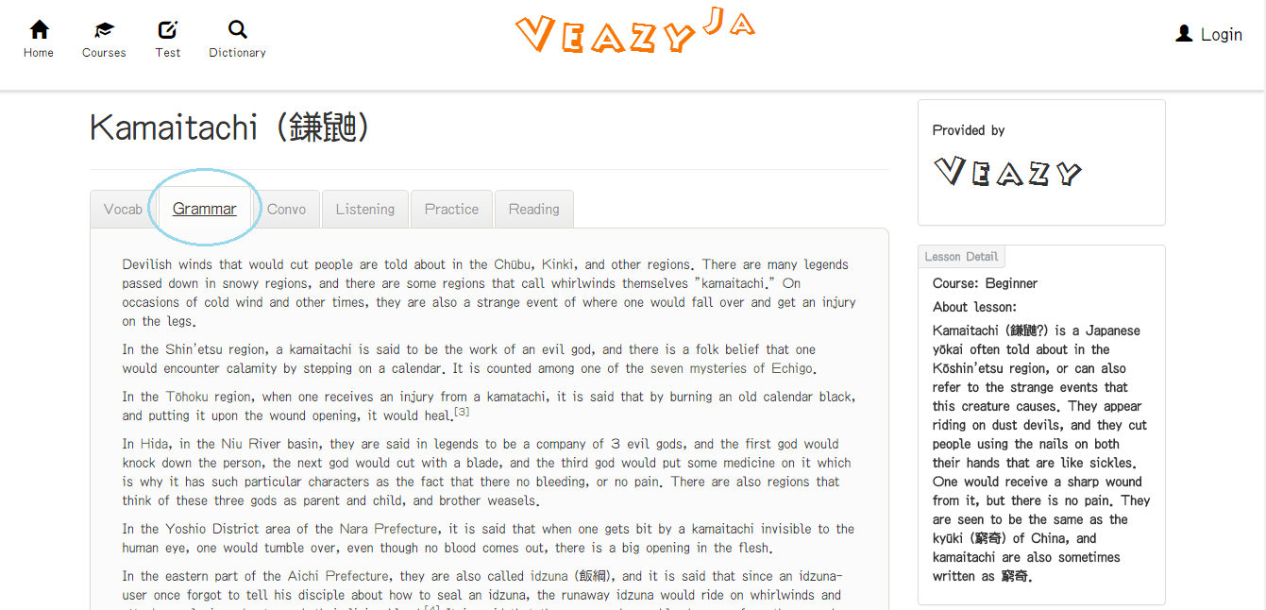

#### Learn Conversation Skill

To learn conversation on website, the users do the steps below:

Step 1: User clicks “Convo” link in “Lessons” page

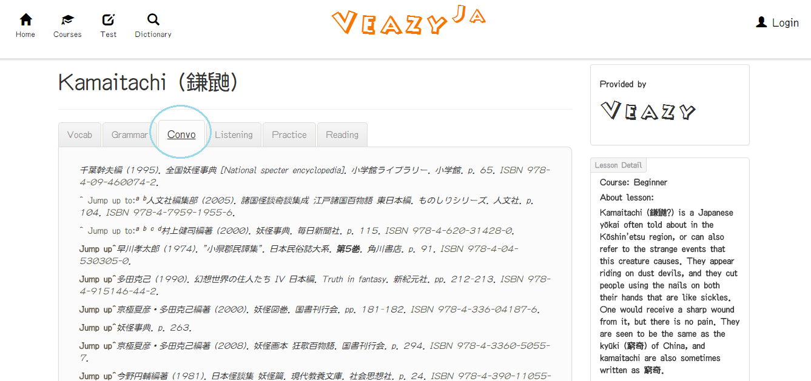

#### Learn Listening Skill

To listening on website, the users do the steps below:

Step 1: User clicks “Listening” link in “Lessons” page

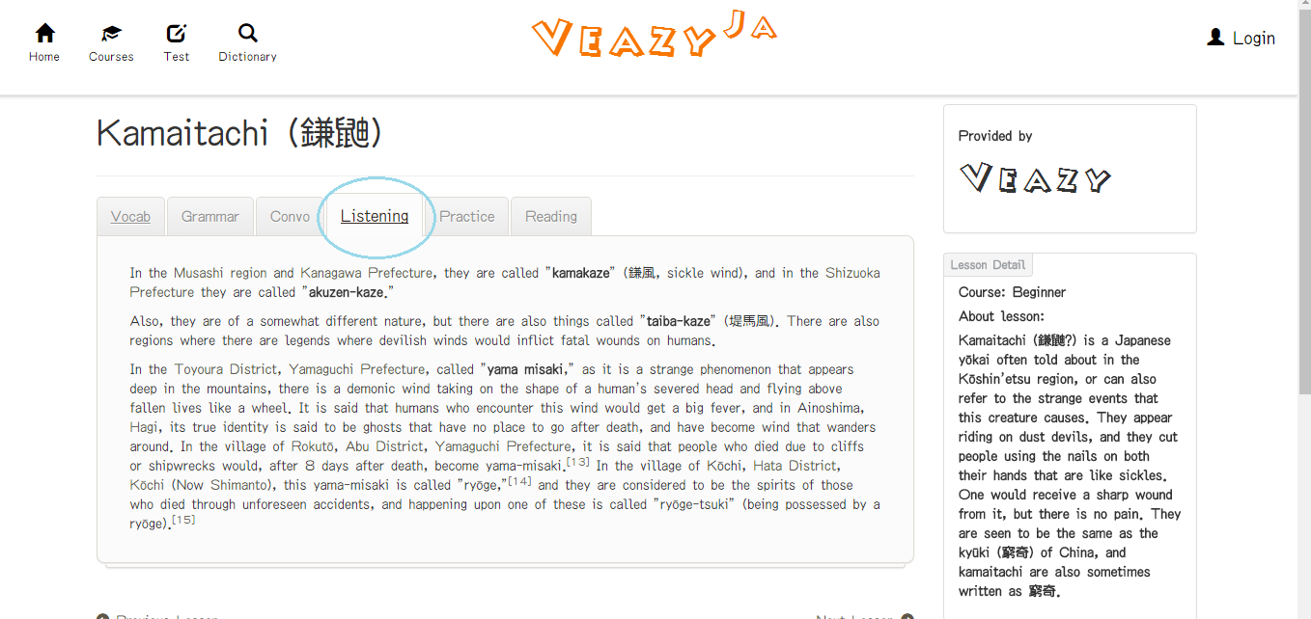

#### Do Practice

To do practice on website, the users do the steps below:

Step 1: User clicks “Pratice” link in “Lessons” page

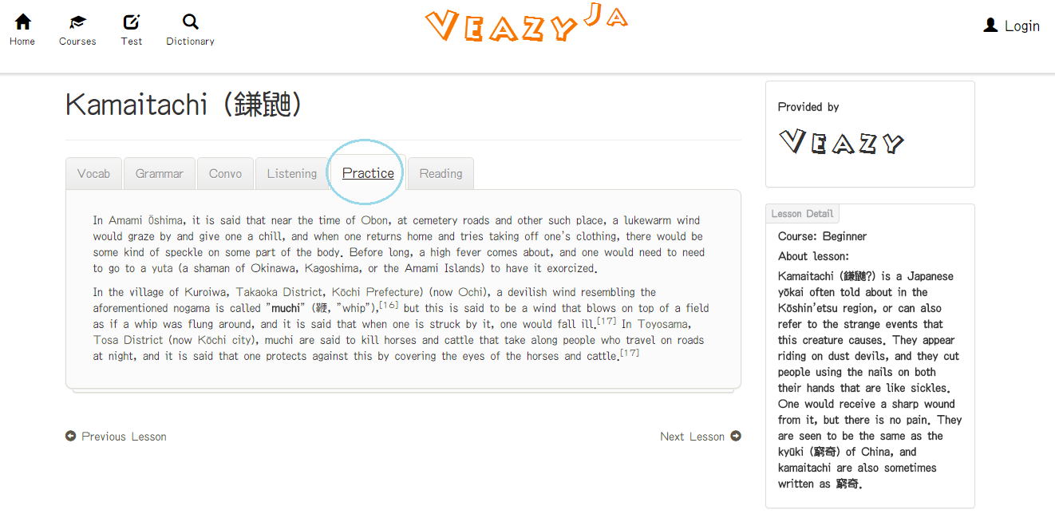

#### Learn reading skill

To reading on website, the users do the steps below:

Step 1: User clicks “Reading” link in “Lessons” page

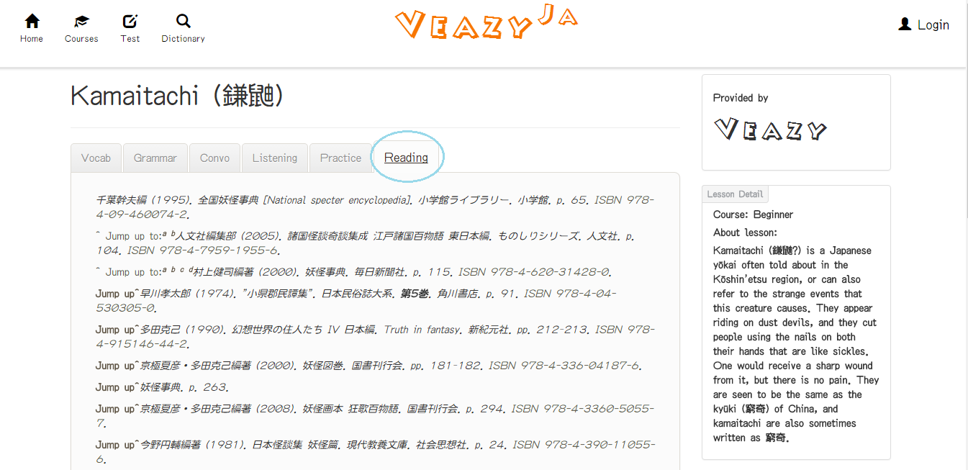

#### Previous Lesson

To previous lesson on website, the users do the steps below:

Step 1: User clicks “Previous Lesson” link in “Lessons” page

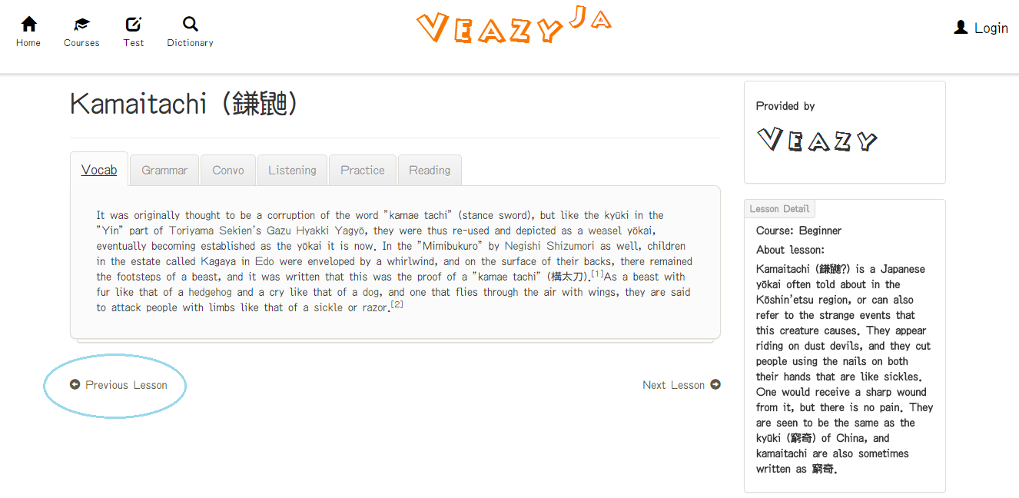

#### Next Lesson

To next lesson on website, the users do the steps below:

Step 1: User clicks “Next Lesson” link in “Lessons” page

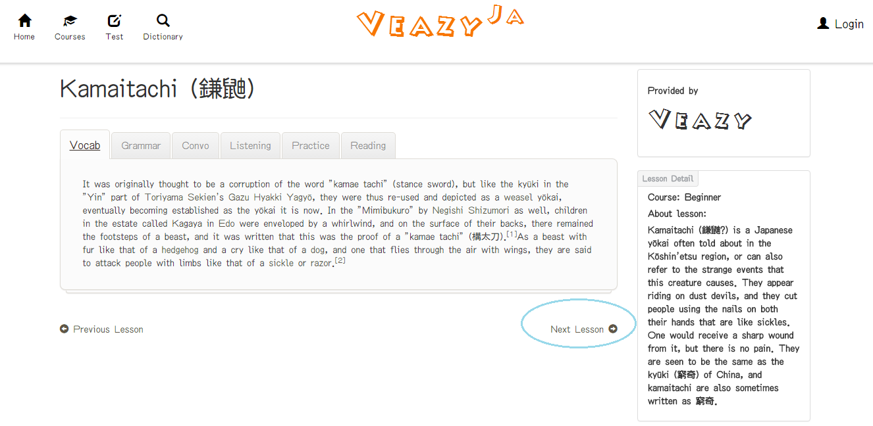

### How to Test

#### Start Create Test

To create test on website, the users do the steps below:

Step 1: User clicks on “Test” link at the top menu in homepage

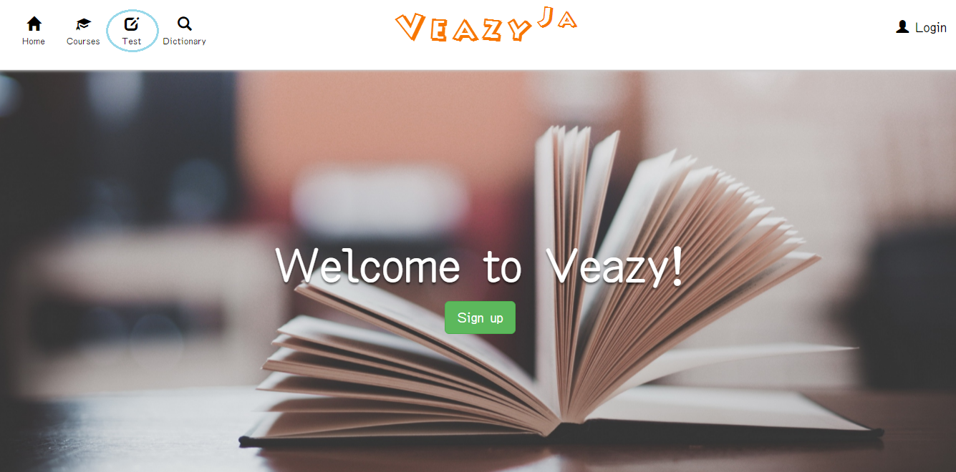

Step 2: Systems redirects to “Test” page

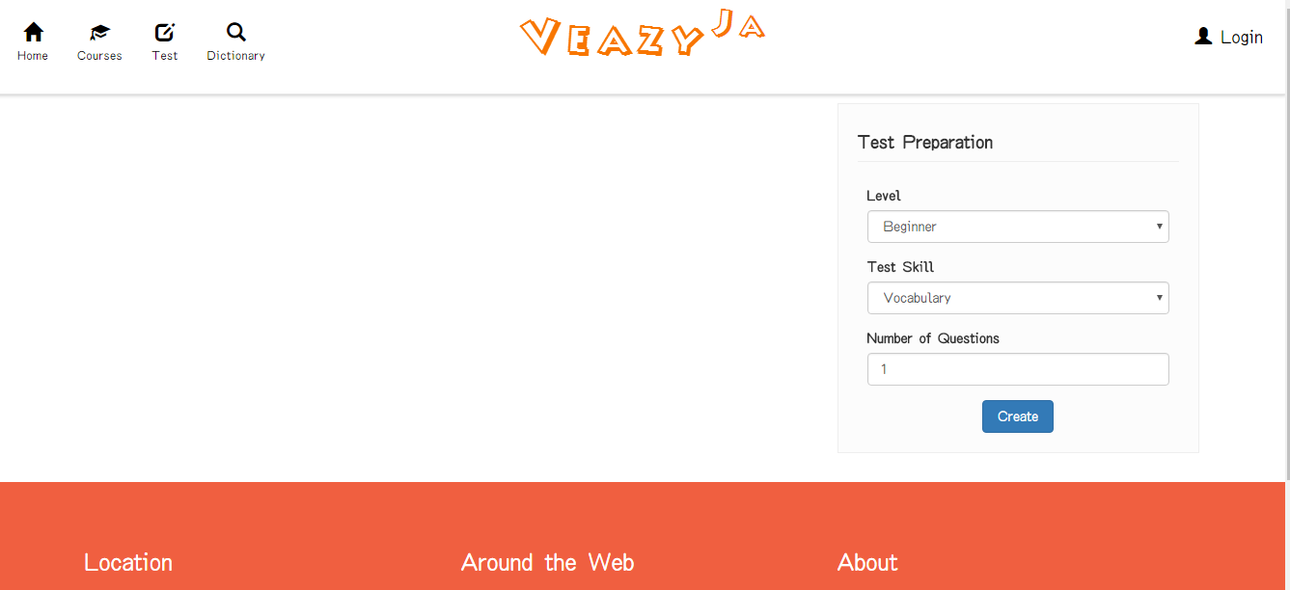

Step 3: User clicks on “Level” dropdown list to select difficulty level and click on “Test skill” dropdown list to select the skill that user wants to test and input the number of questions

Step 4: Click on “Create” button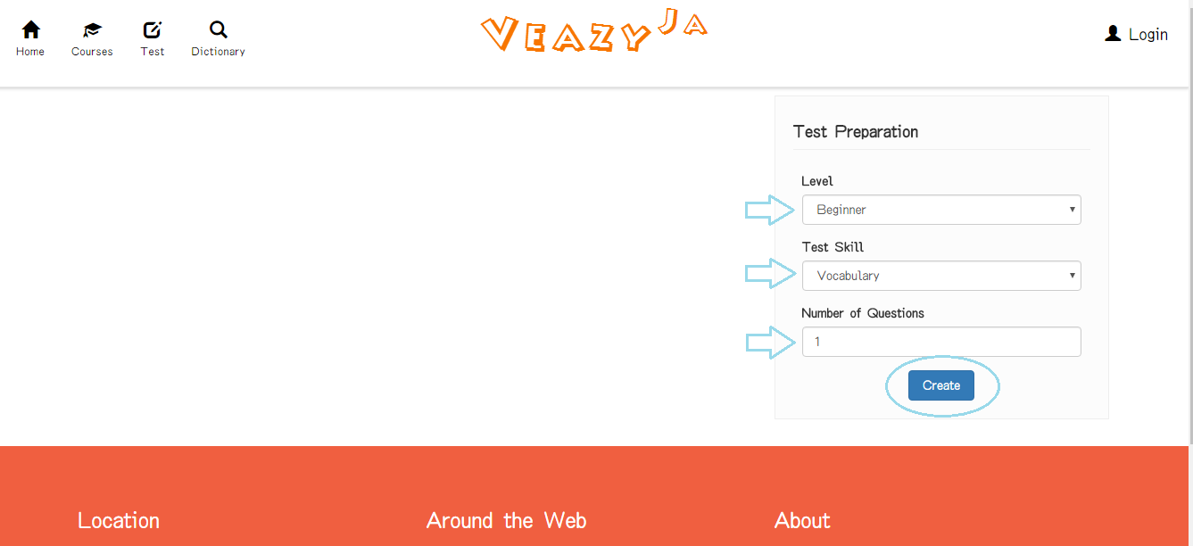

Step 5: System shows test

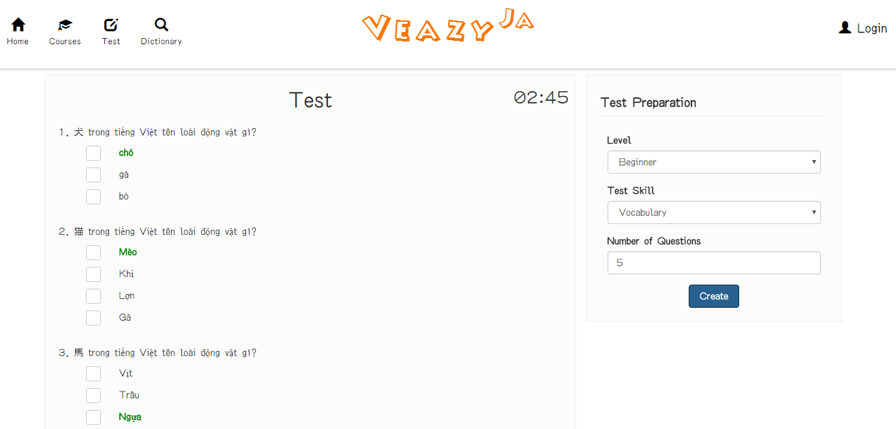

#### Submit Test

To view result test on website, the users do the steps below:

Step 1: User clicks on “Submit” button in take test page

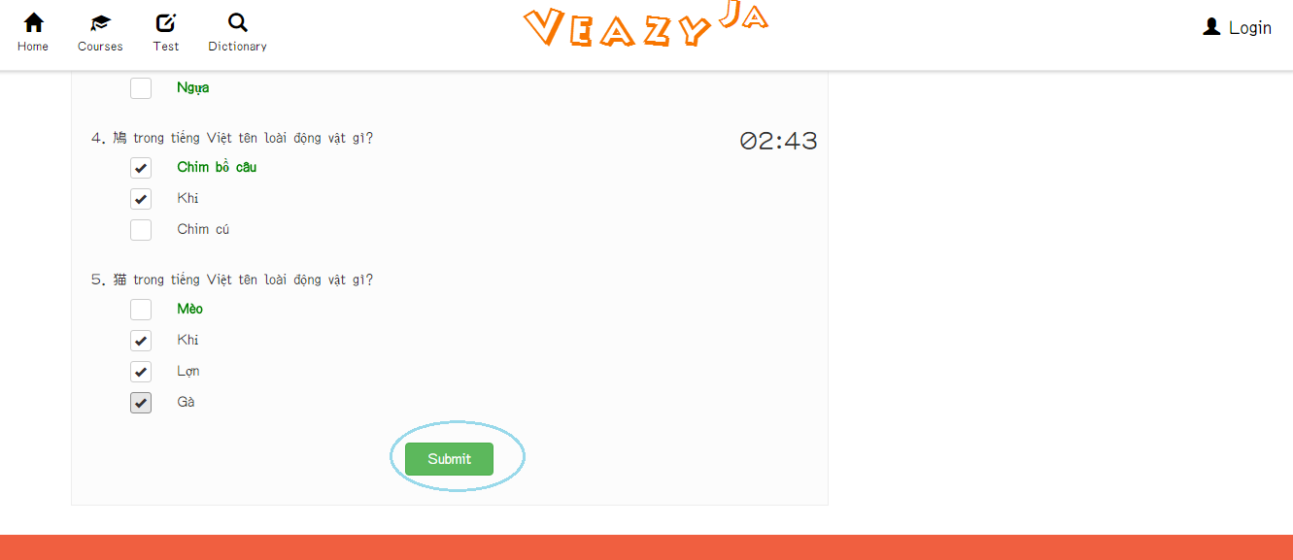

Step 2: System redirects to test result page

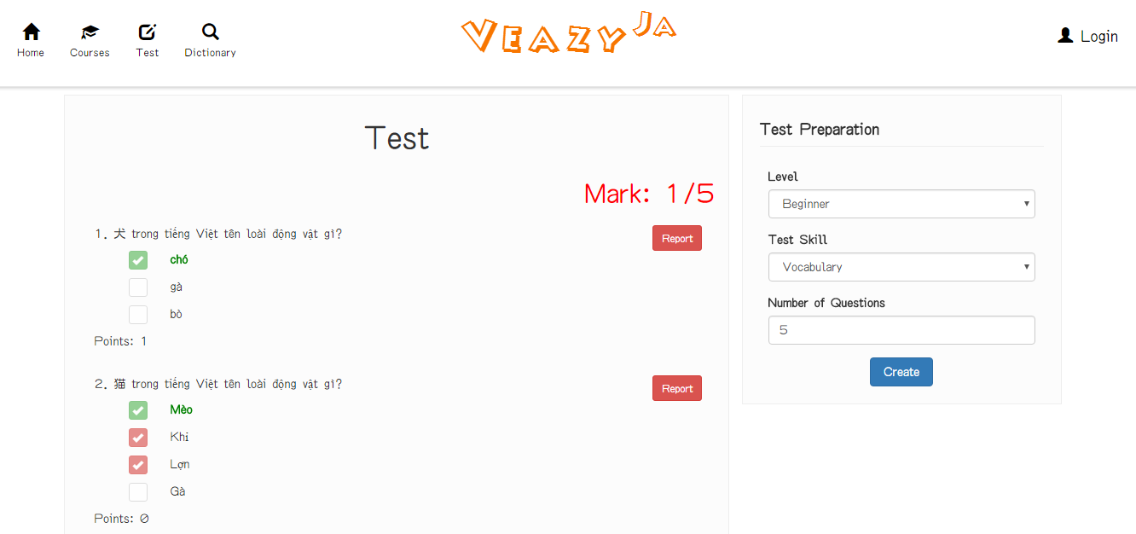

### User is Member

Member logged in the website

#### Sent Question Report

To report question on website, the users do the steps below:

Step 1: User clicks on “Report” button in “Test Result” page

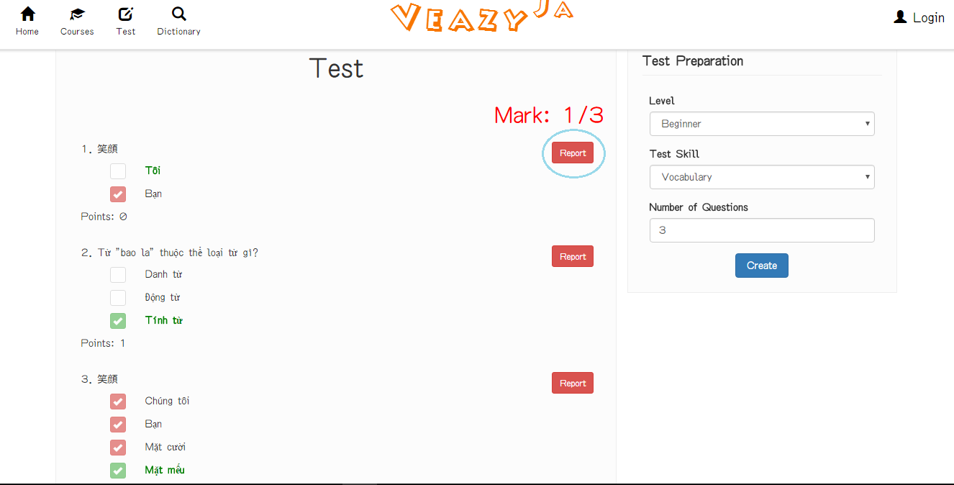

Step 2: User inputs content message

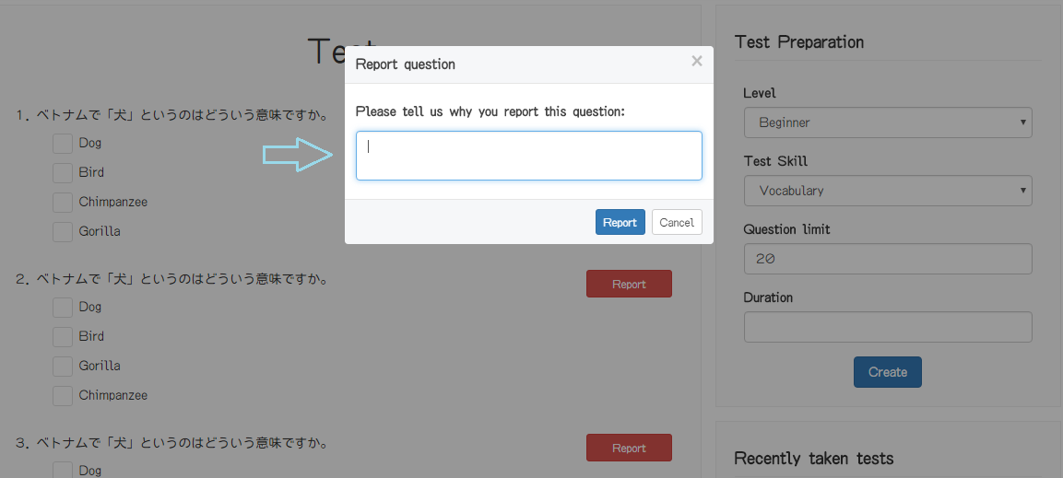

Step 3: User clicks on “Report” button in “Report question” popup

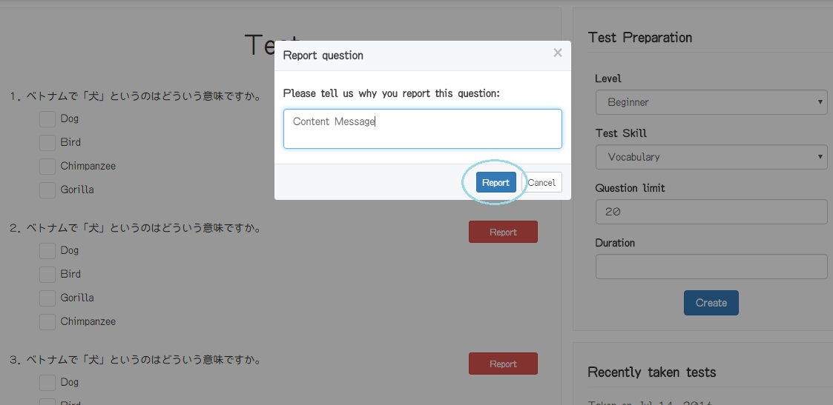

#### View List Test History

To view list test history on website, the users do the steps below:

Step 1: User clicks on “Test” link at the top menu in homepage

#### View Test History

#### Retake Test

#### View Member Profile

To view profile on website, the users do the steps below:

Step 1: User clicks on username hyperlink at the right top of menu

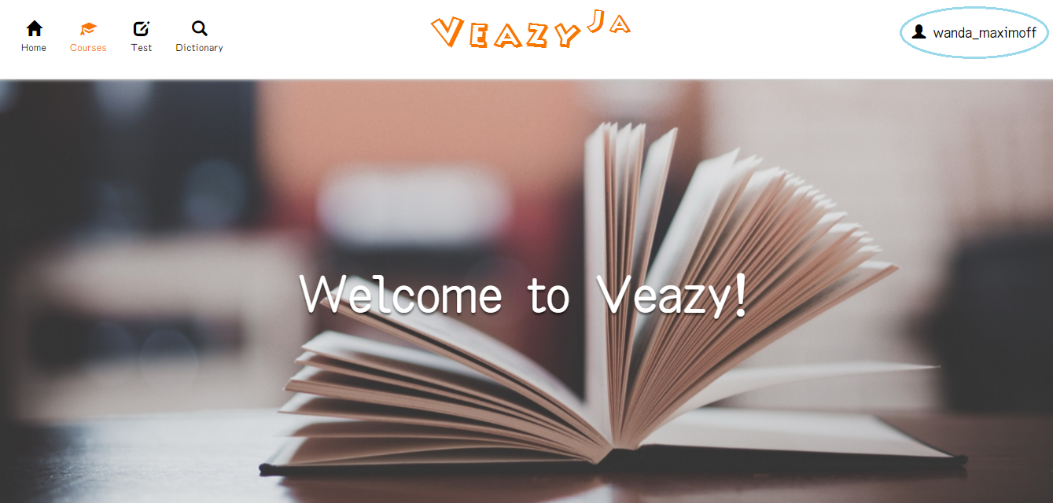

Step 2: Click on “Show Profile” hyperlink in dropdown list

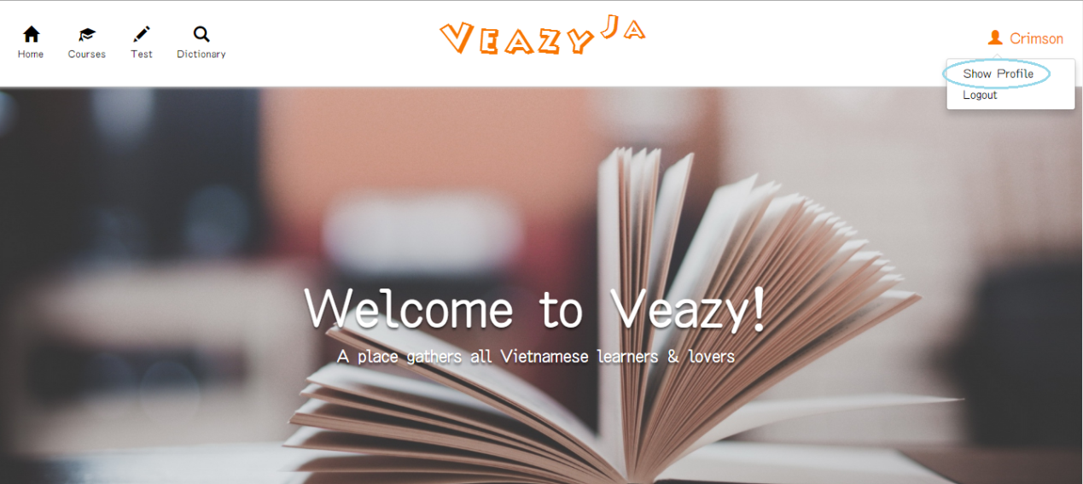

Step 3: System redirects to “Profile” Page if view profile successful

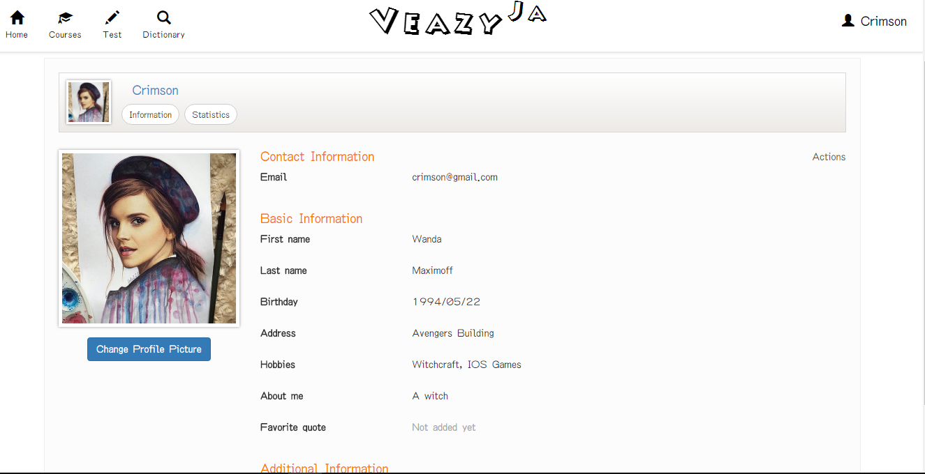

#### Update Profile

To update profile on website, the users do the steps below:

Step 1: User clicks on “Update Profile” in “Actions” dropdown list

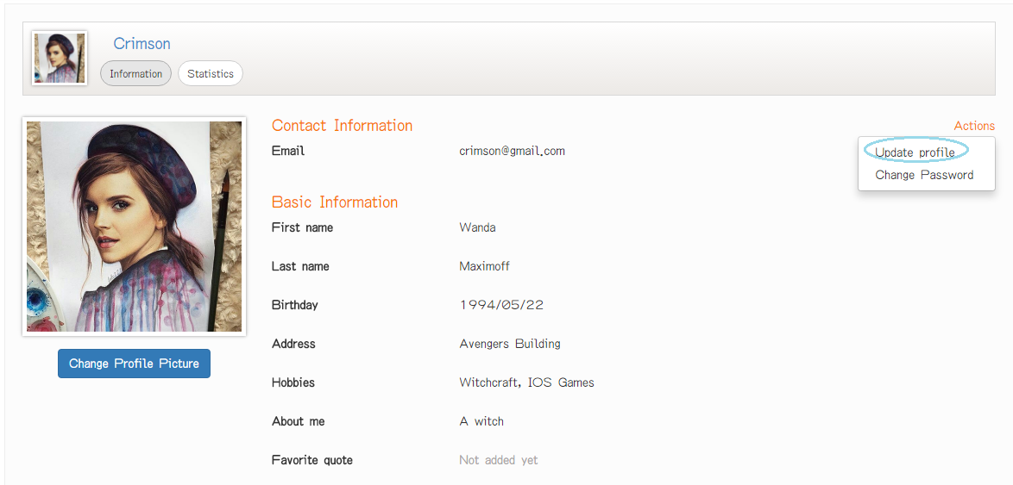

Step 2: Update information

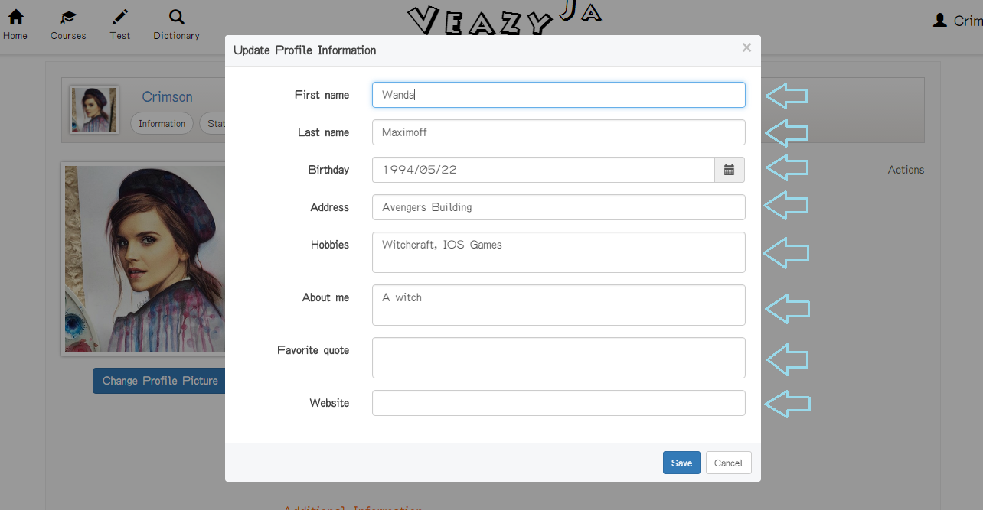

Step 3: User clicks on “Save” button

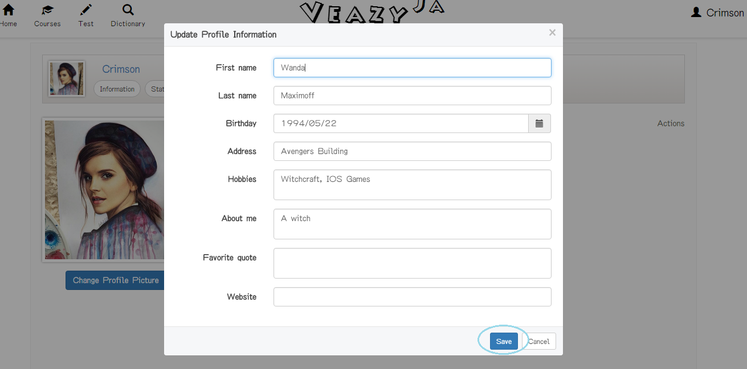

If user clicks “Cancel’ button, system cancel editing profile action and close “Update Profile Information” popup

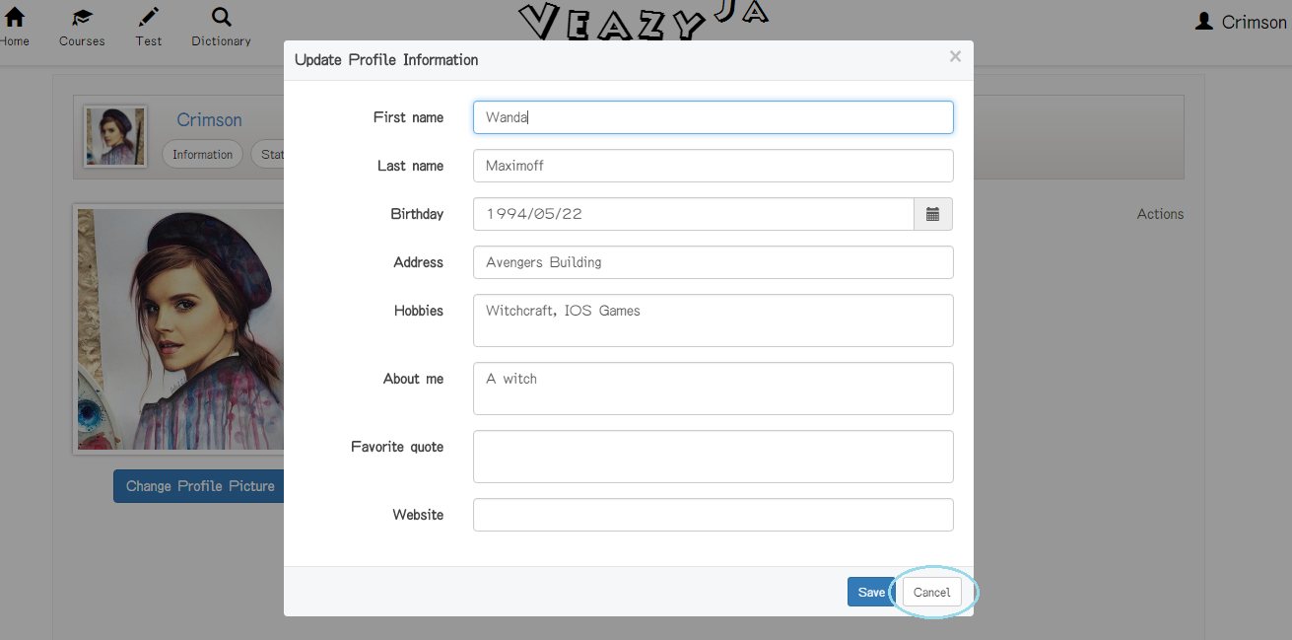

#### Change Password

To update profile on website, the users do the steps below:

Step 1: User clicks on “Change Password” in “Actions” dropdown list

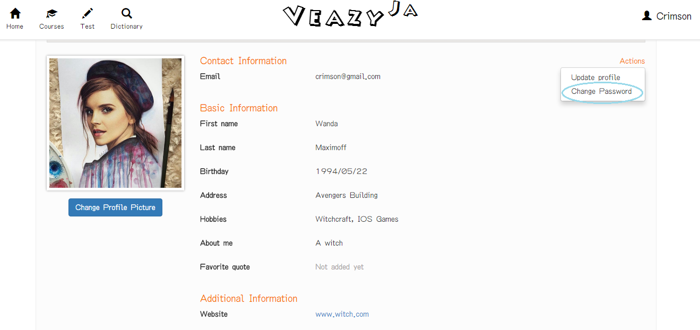

Step 2: Input information

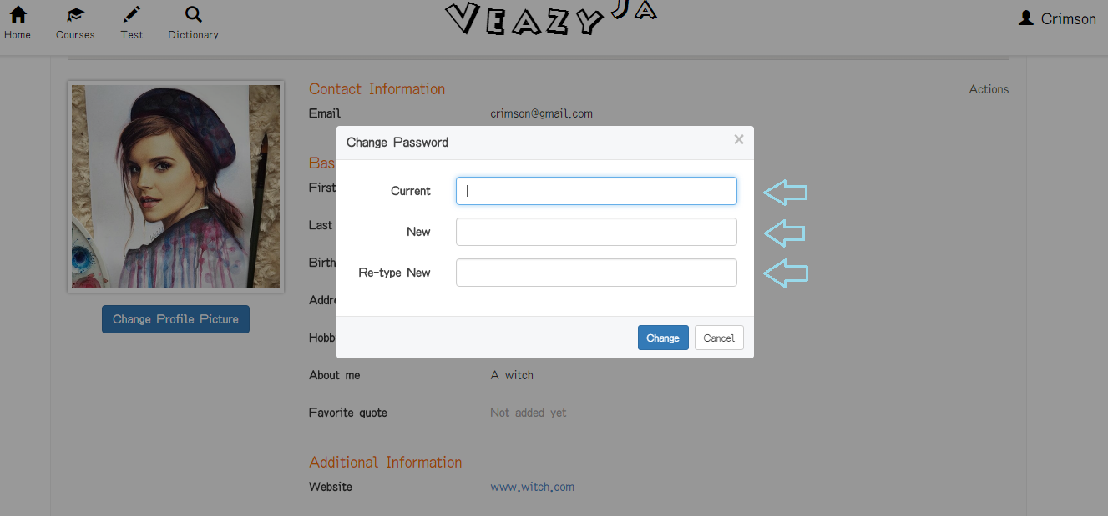

Step 3: Click on “Change” button.

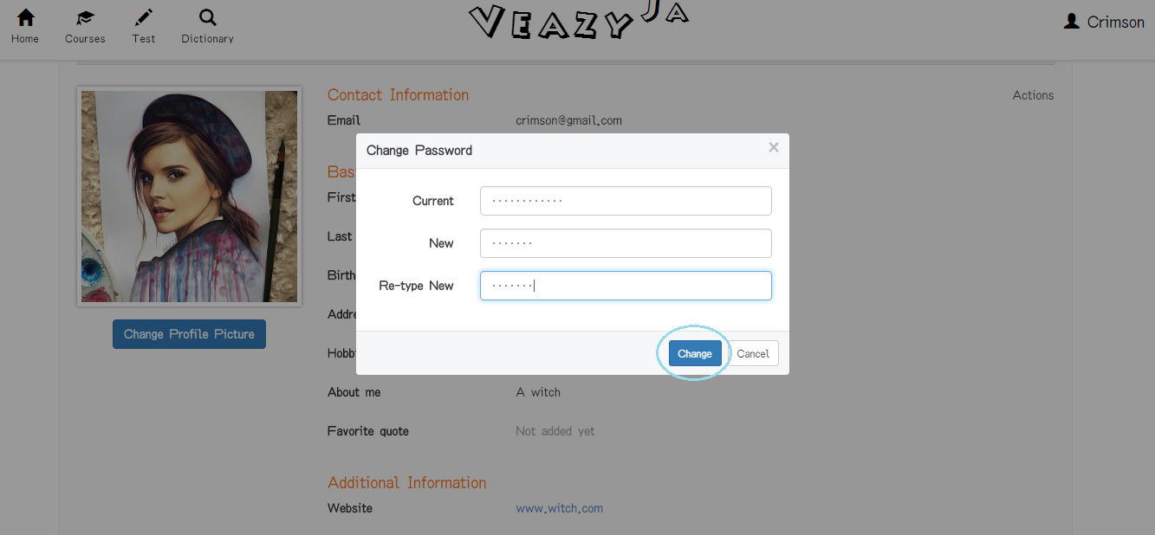

If user clicks “Cancel’ button, system cancel change password action and close “Change Password” popup

#### Change Profile Picture

#### View Statistics

To view statistics on website, the users do the steps below:

Step 1: User clicks on “Statistics” button in “Profile” page

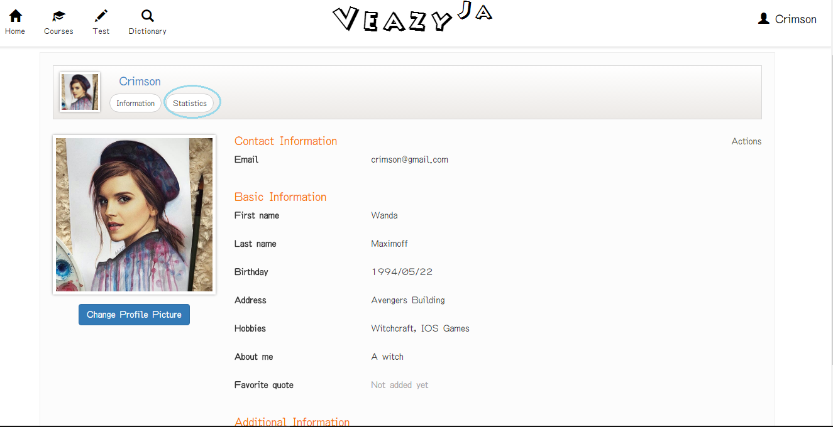

Step 2: System show statistics tab

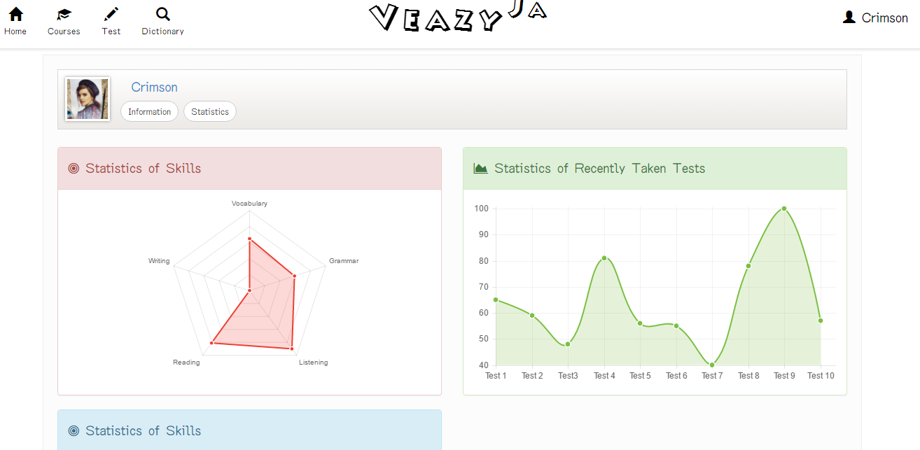

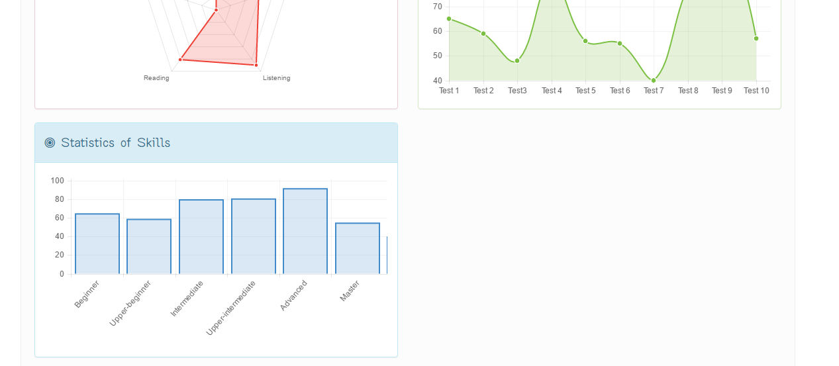

### The User is Content Editor

Content Editor logged in the website

#### View Profile

#### Update Profile

#### Change Password

#### Change Profile Picture

#### Logout

To logout on website, the users do the steps below:

Step 1: User clicks on “Logout” link in sidebar

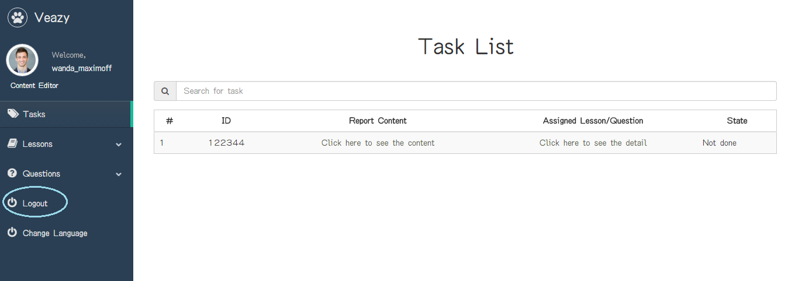

Step 2: Systems redirects to “Login” page

#### View Lessons List

To view lessons list on website, the users do the steps below:

Step 1: Click on “Lessons” link at dashboard

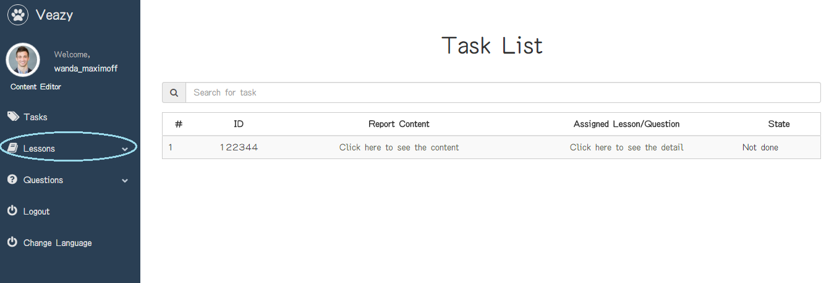

Step 2: User clicks on “Lesson List” hyperlink at dashboard in editor dashboard page

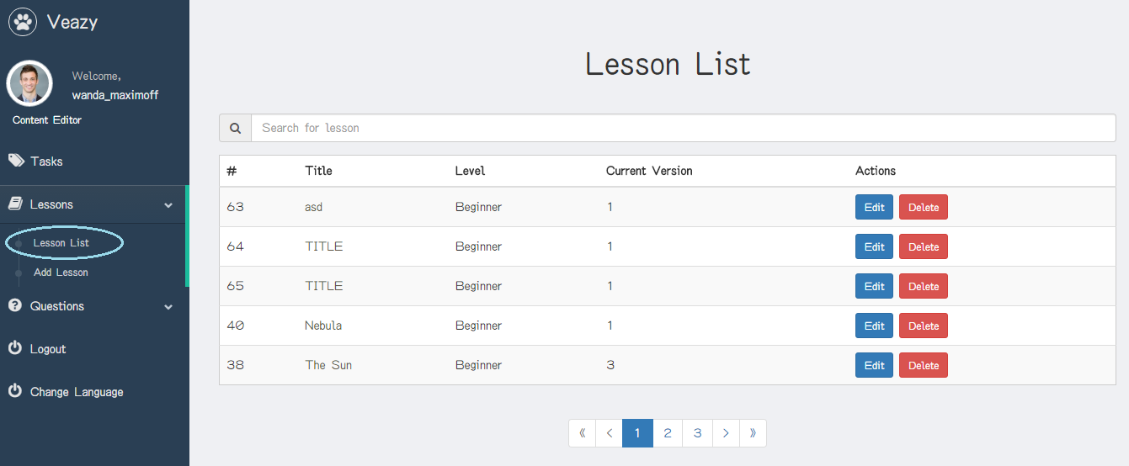

Step 3: System redirects to lesson list page

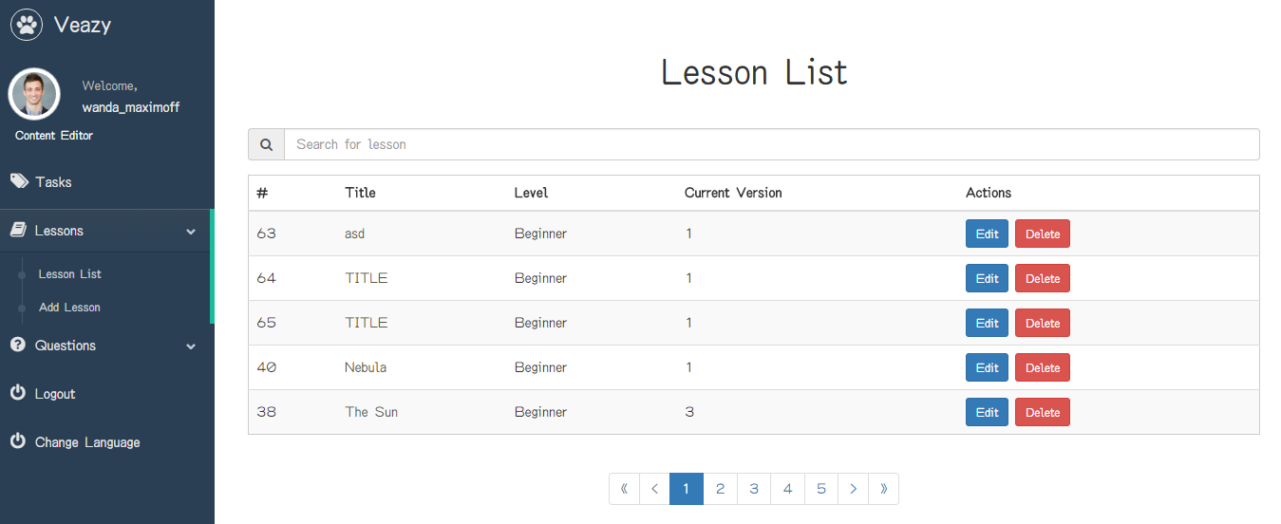

#### Search Lesson

To search lesson on website, the users do the steps below:

Step 1: User inputs text to the search box

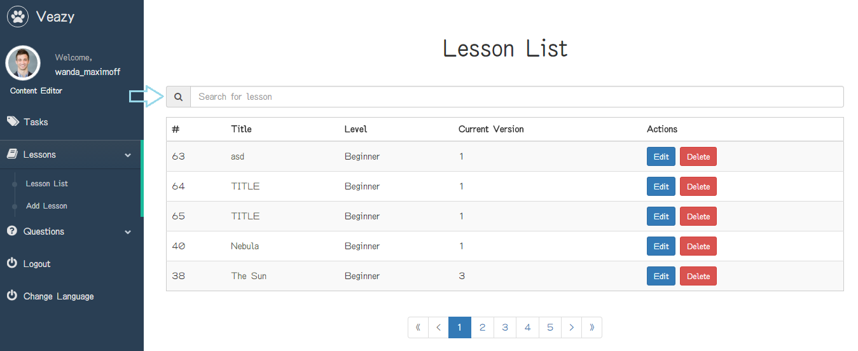

Step 2: User clicks on “Search” button

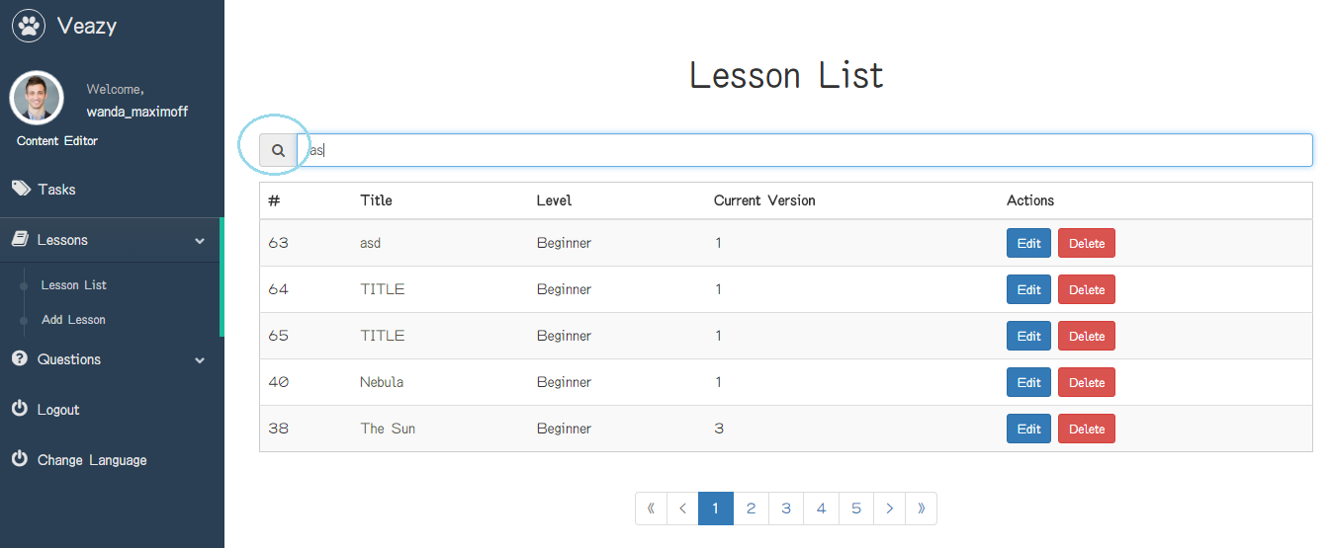

Step 3: System will filter and display result if search lesson successful

#### View Lesson Details

To view lesson details on website, the users do the steps below:

Step 1: User clicks on title name link of table in lesson list page

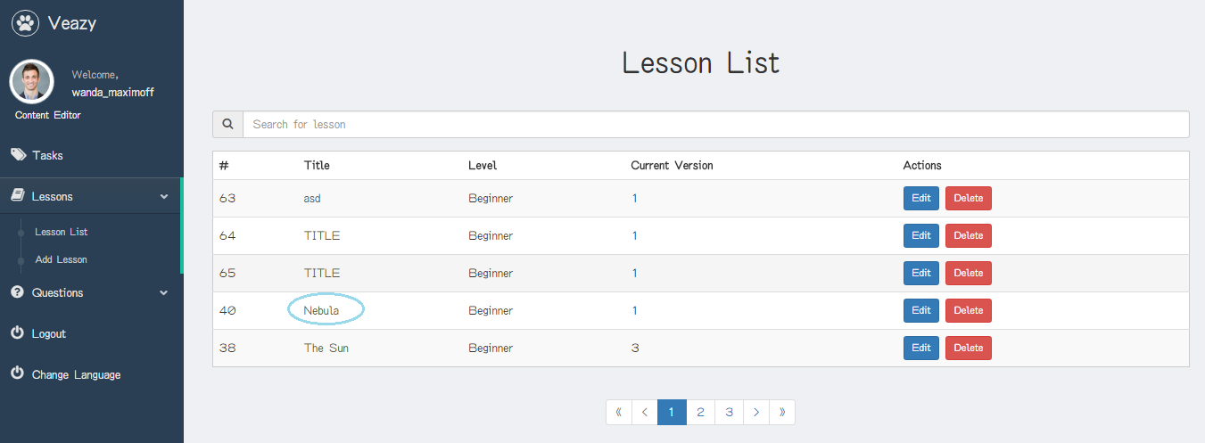

Step 2: System redirects to lesson details page if view lesson details successful

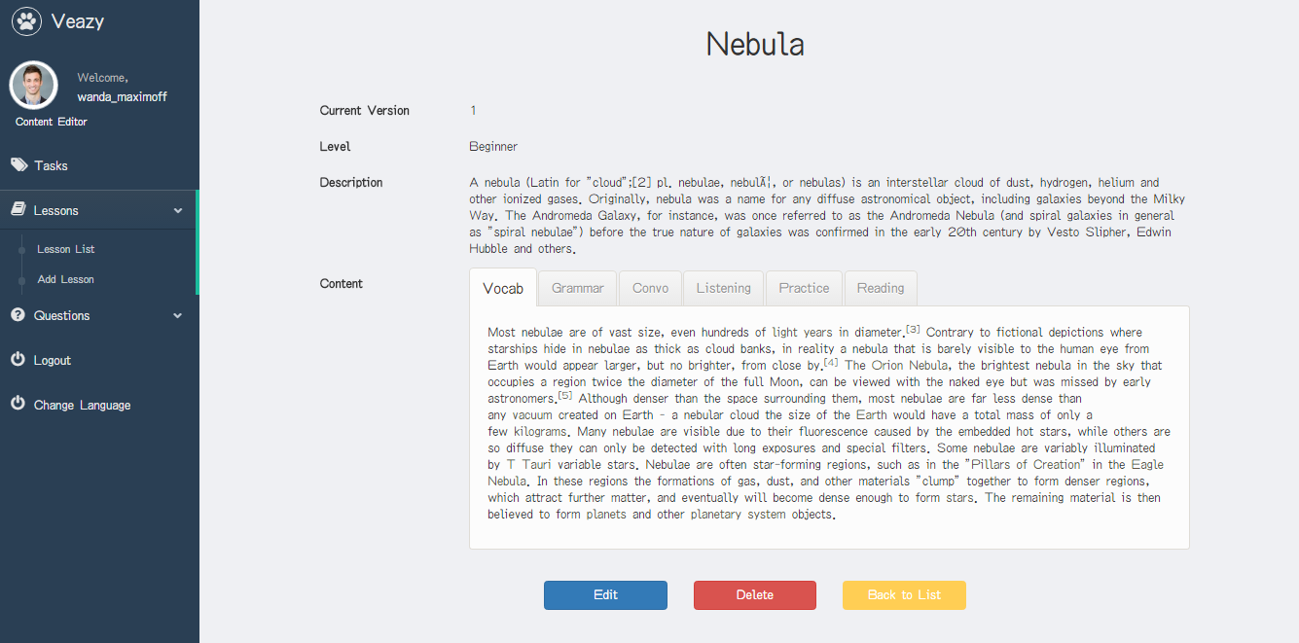

#### Create Lesson

To create lesson on website, the users do the steps below:

Step 1: User clicks on “Lessons” link at dashboard



Step 2: User clicks on “Add Lesson” hyperlink at dashboard in editor dashboard page

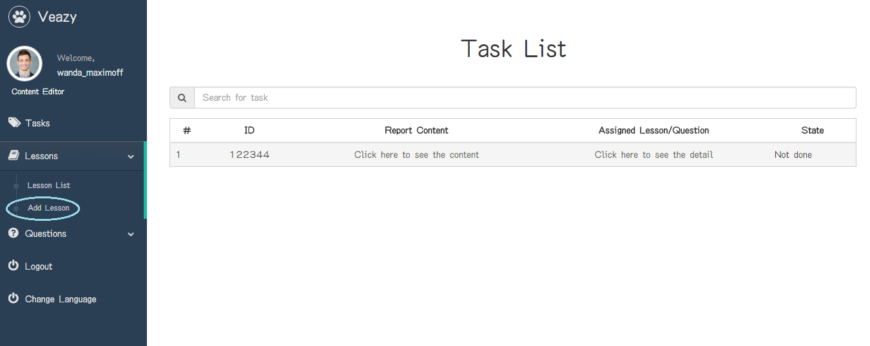

Step 3: User inputs information

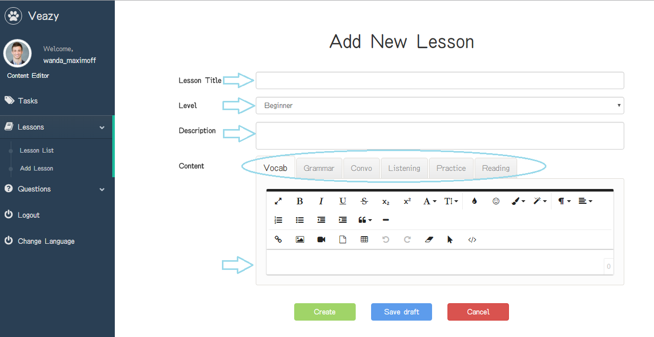

Step 4: User clicks on “Create” button

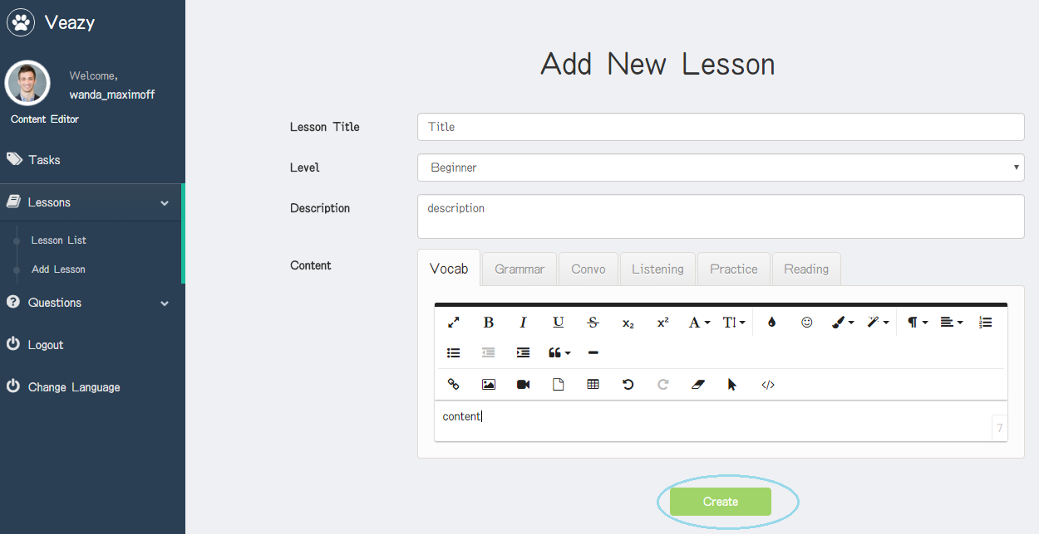

Step 5: System redirects to lesson list page and add new lesson

#### Save Draft Lesson

To save draft lesson on website, the users do the steps below:

Step 1: User clicks on “Save draft” button in edit lesson page

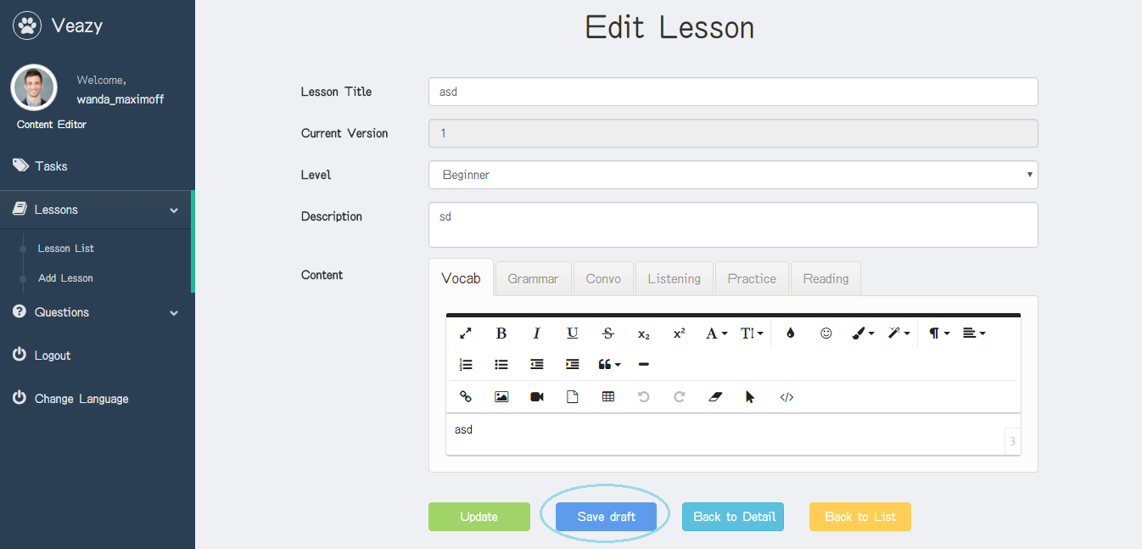

#### Edit Lesson

To edit lesson on website, the users do the steps below:

Step 1: User clicks on “Edit” button in lesson list page

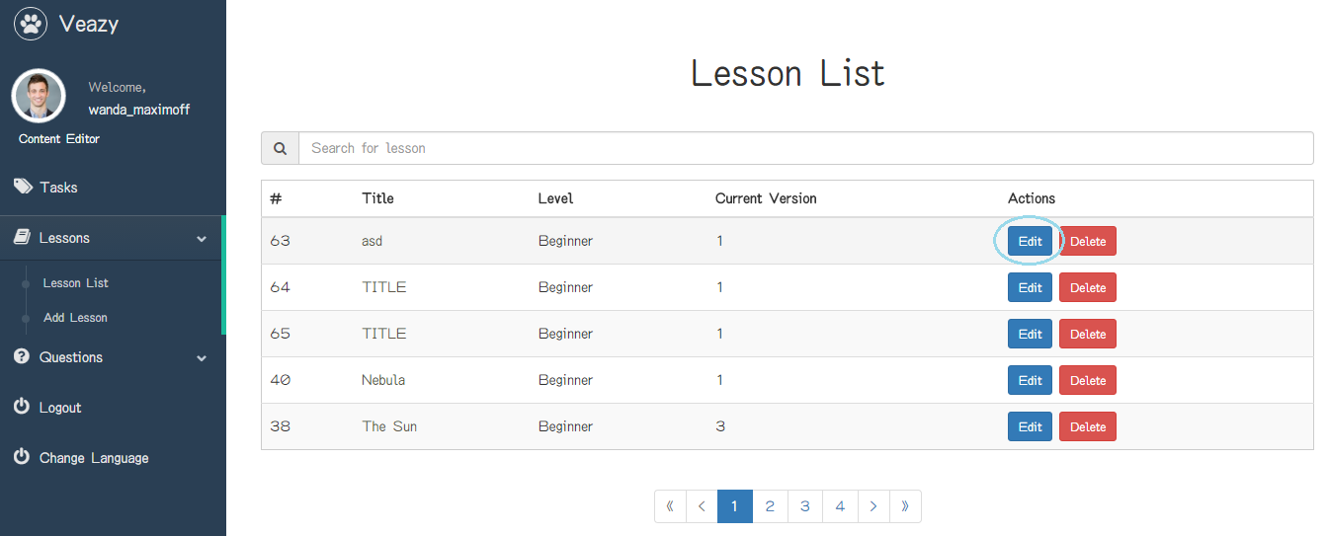

Step 2: User updates information

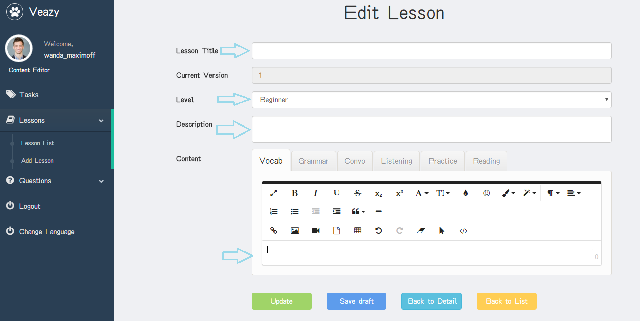

Step 3: User clicks on “Update” button

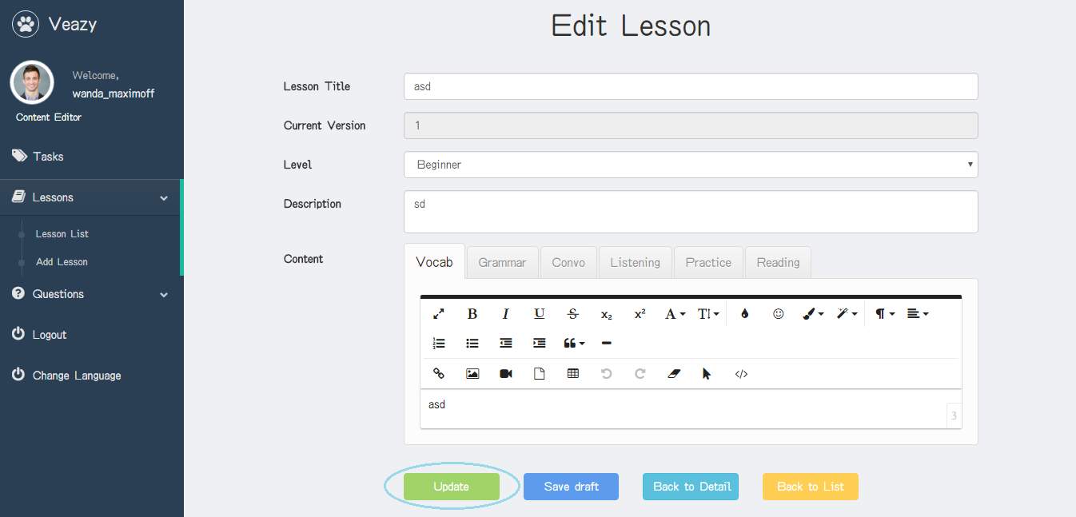

#### Delete Lesson

To delete lesson on website, the users do the steps below:

Step 1: User clicks on “Delete” button in lesson list page

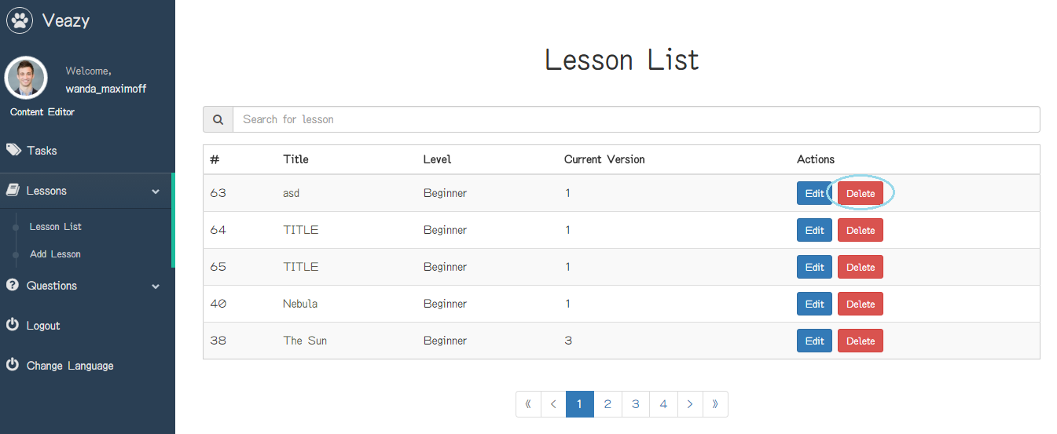

Step 2: User clicks on “Delete” button in “Delete Lesson” popup

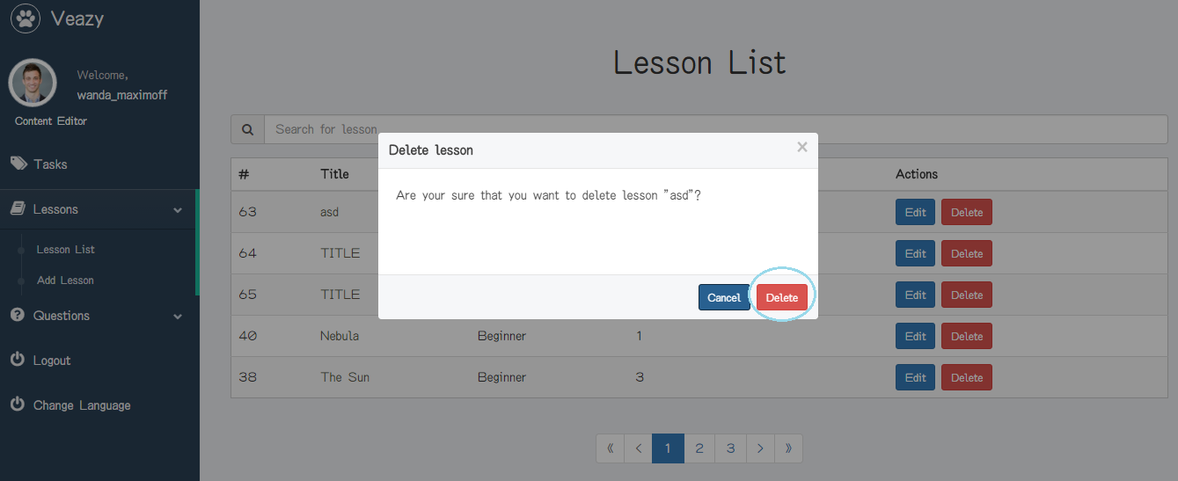

#### View Lesson Report

To view lesson report, the users do the steps below:

Step 1: User clicks on “Tasks” link at dashboard in content editor dashboard page

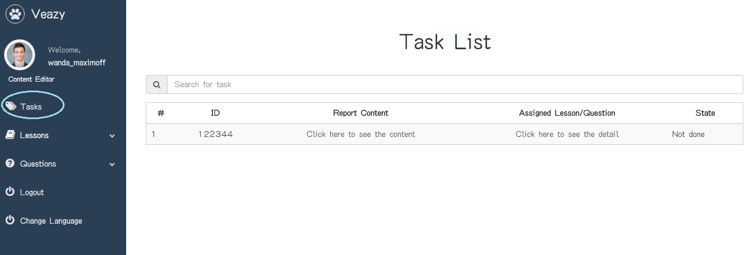

Step 2: System redirects to view report page

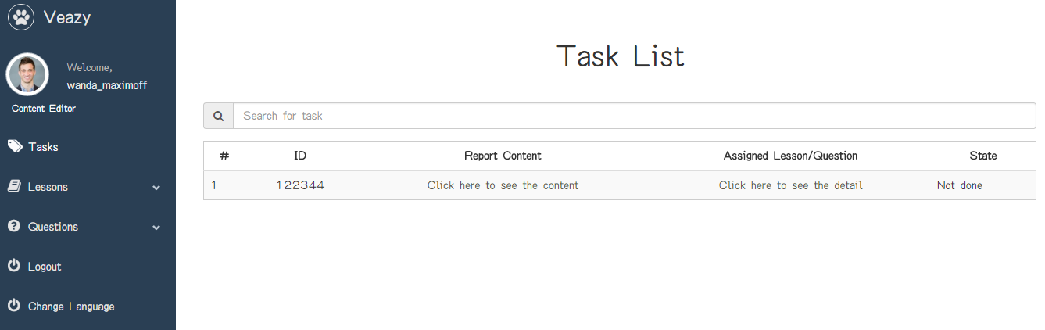

#### View Questions List

To view question list on website, the users do the steps below:

Step 1: User clicks on “Questions” link at dashboard

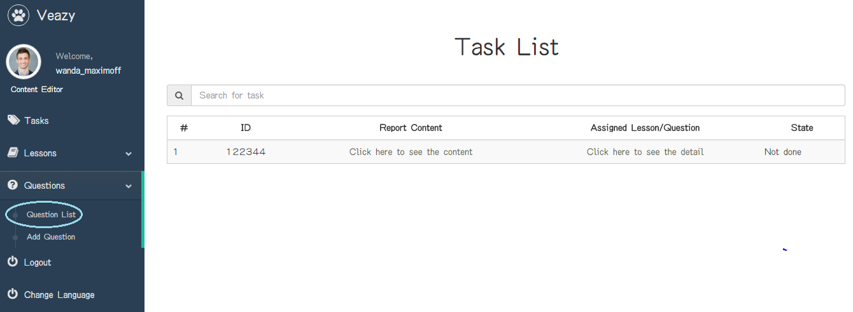

Step 2: User clicks on “Question List” hyperlink at dashboard in editor dashboard page



Step 3: System redirects to question list page

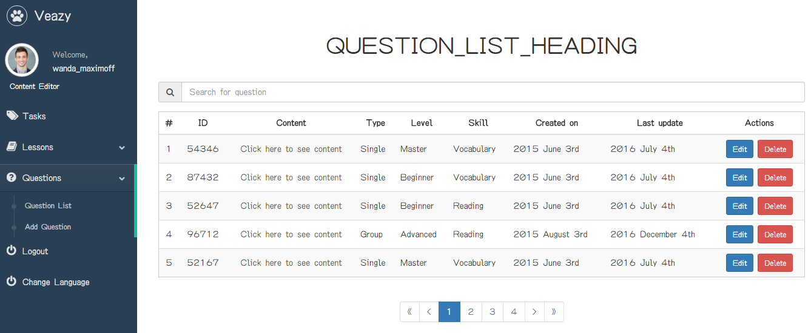

#### Search Question

To search question list on website, the users do the steps below:

Step 1: User inputs text to the search box

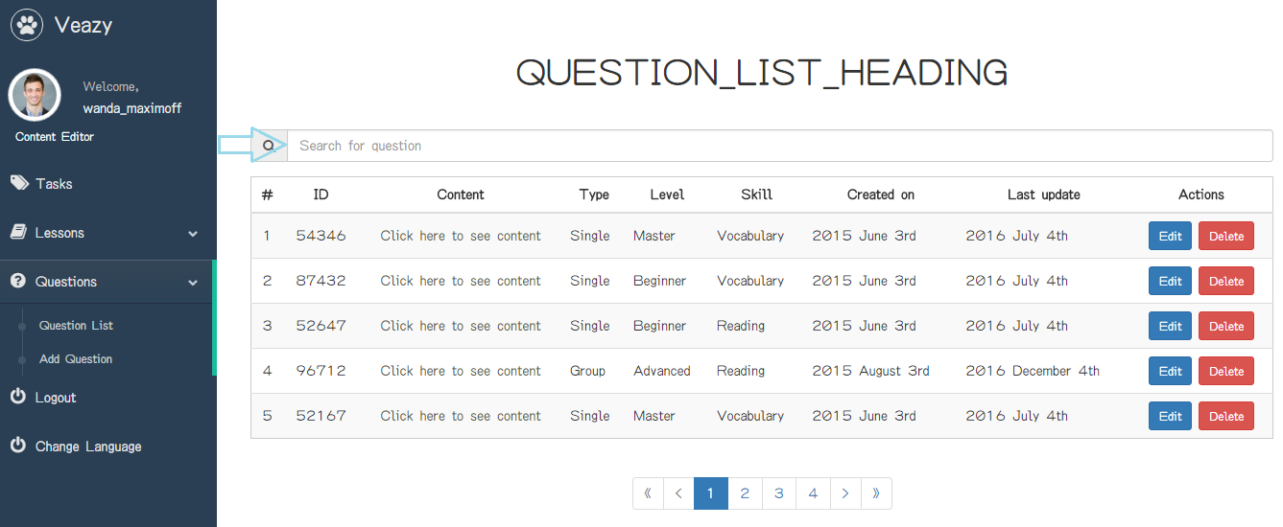

Step 2: User clicks on “Search” button

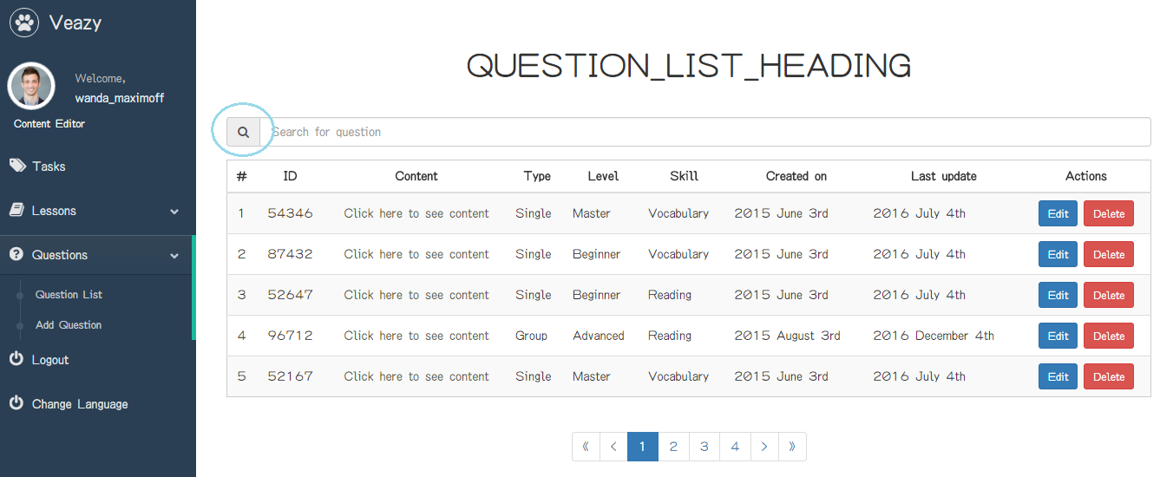

#### View Question Details

To view question details on website, the users do the steps below:

Step 1: User clicks on “Click here to see content” link of each question

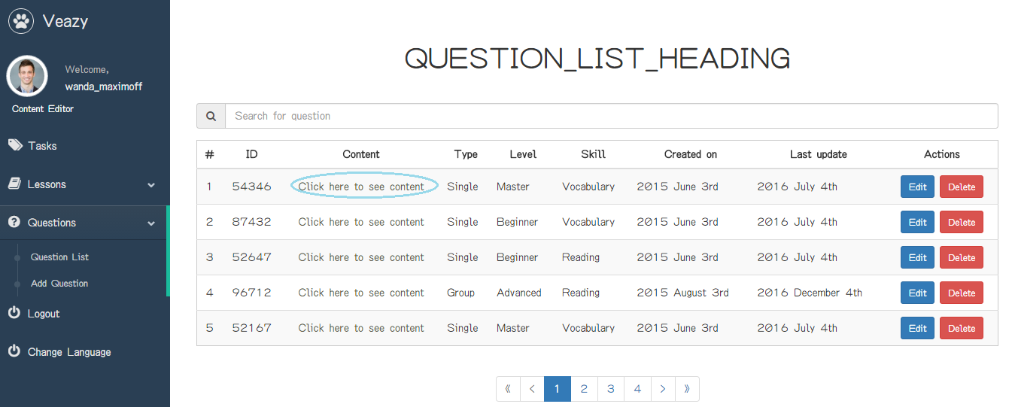

Step 2: System redirects to question details page if view question details successful

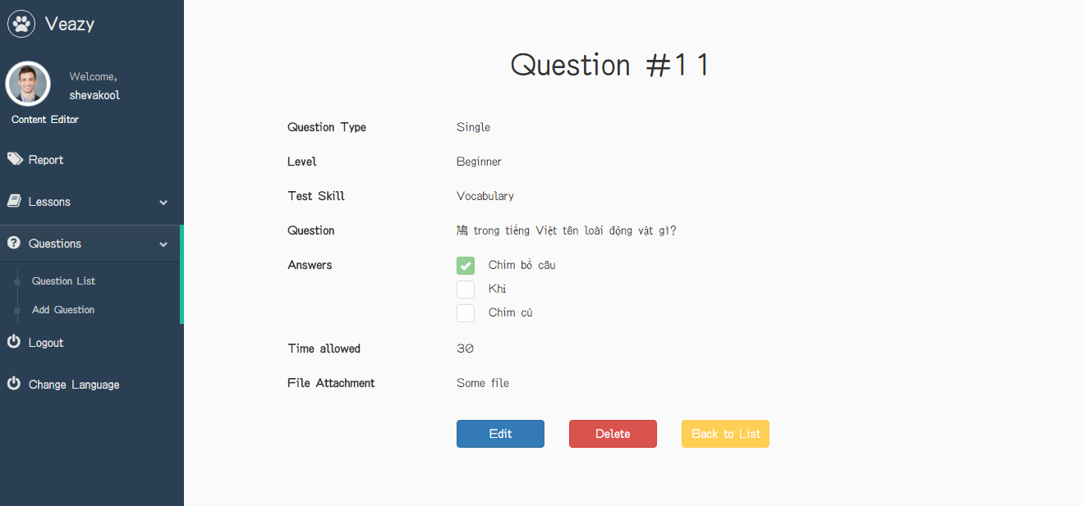

#### Create Single Question

To create single question on website, the users do the steps below:

Step 1: User clicks on “Add Question” hyperlink in “Editor Dashboard” page

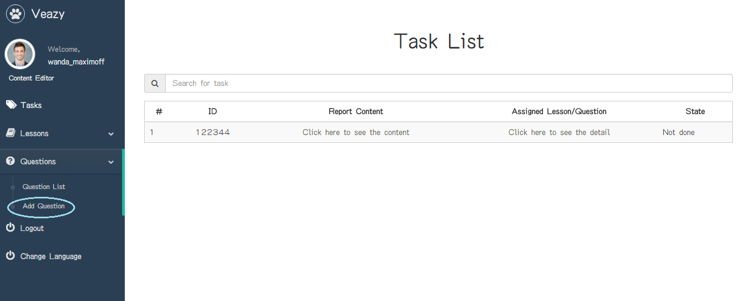

Step 2: User chooses “Single” in “Question Type” dropdown list

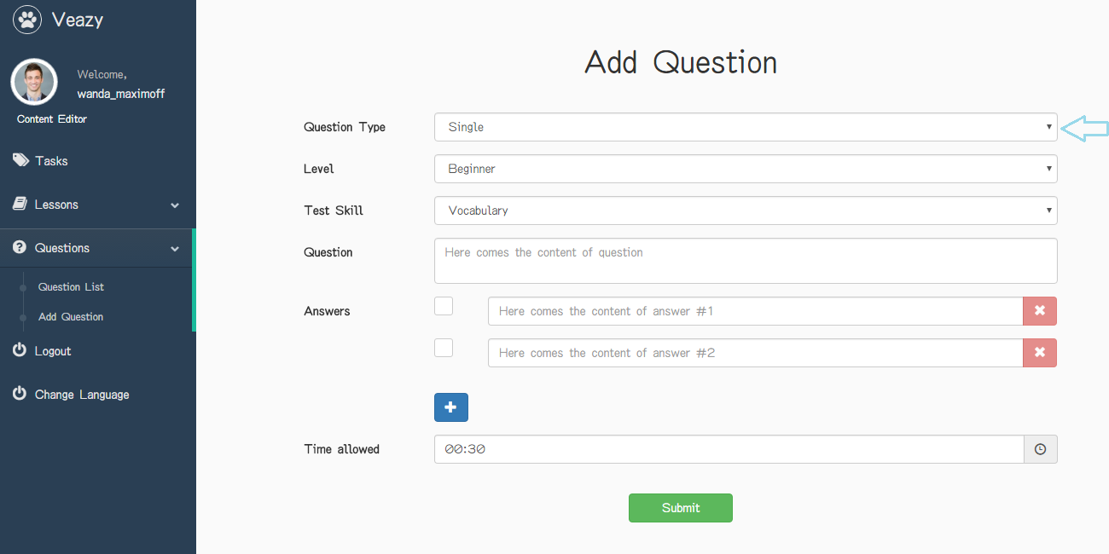

Step 3: User chooses question level in “Level” dropdown list

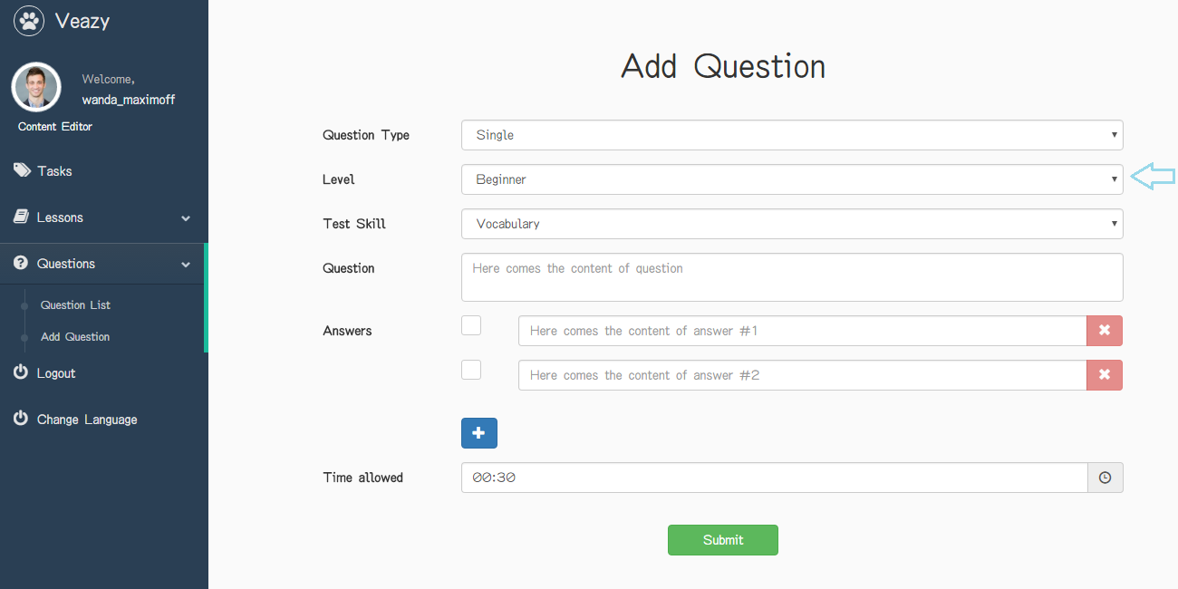

Step 4: User chooses question skill in “Test Skill” dropdown list

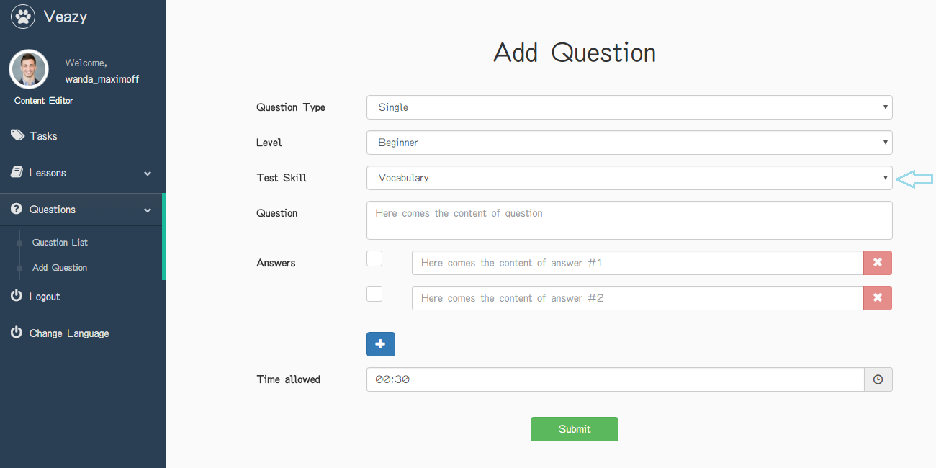

Step 5: User inputs question and answer and choose right answer

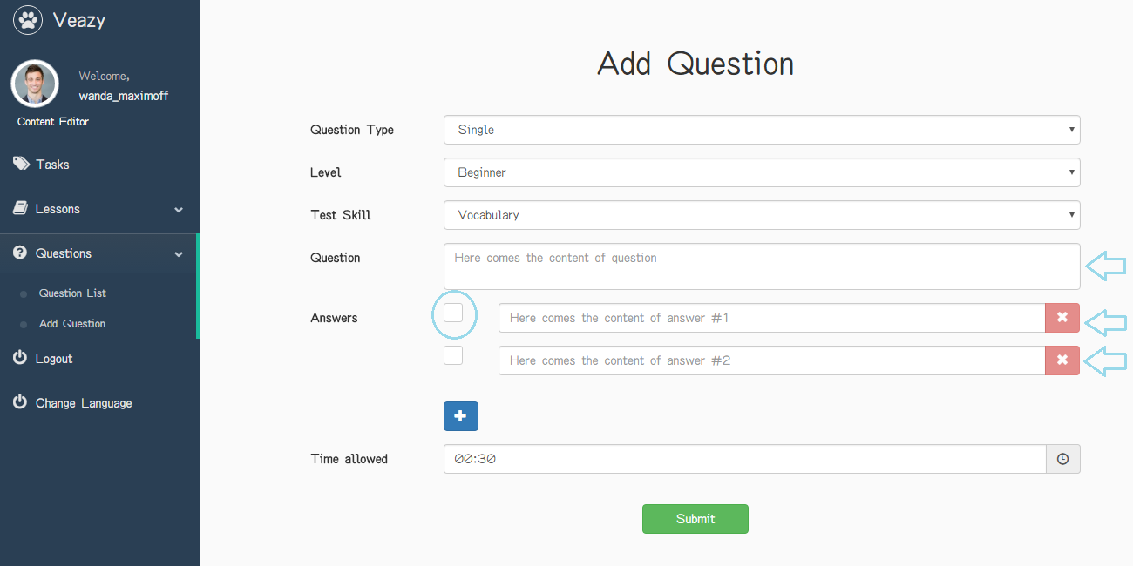

Step 6: User clicks on time icon to select time allowed in section “Time allowed”

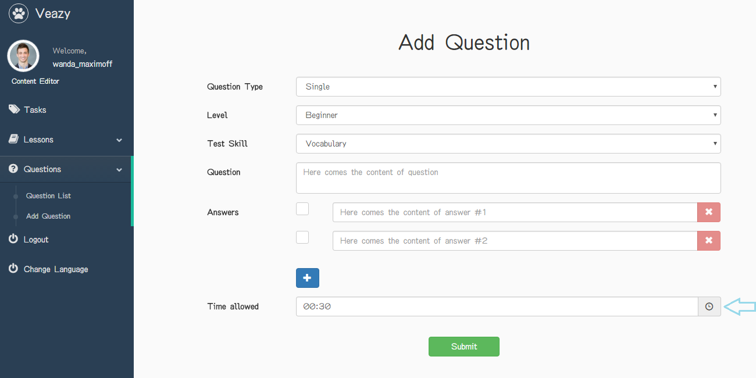

Step 7: Click on “+” button under answer field to add more answer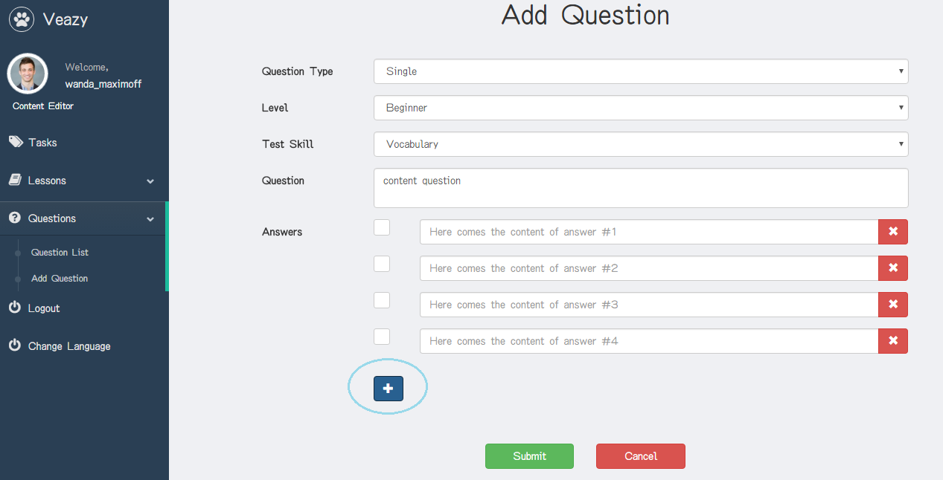

Step 8: User clicks on “x” button under answer field to delete answer

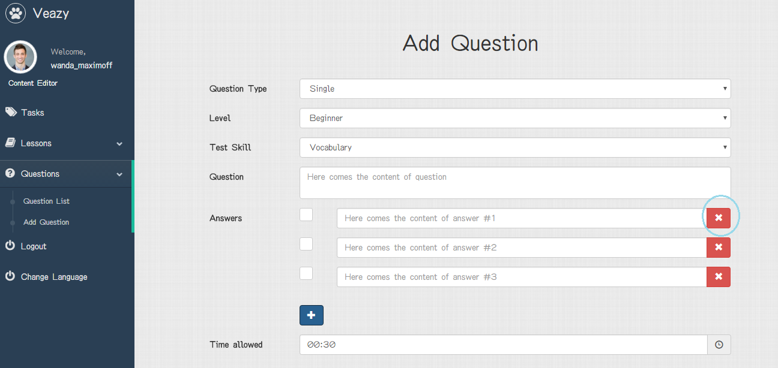

Step 9: User clicks on “Submit” button

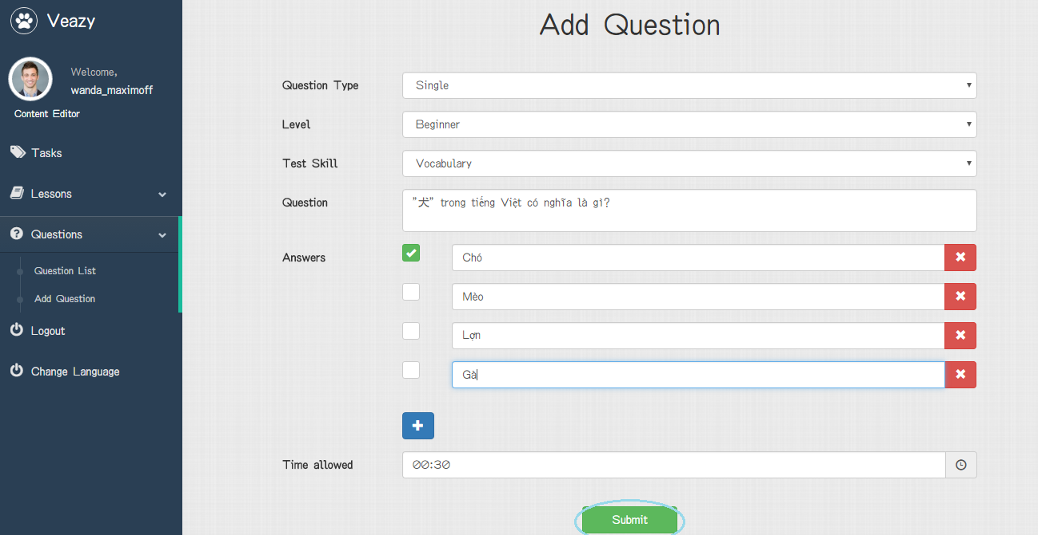

Step 10: System redirects to question list page and add new lesson



#### Create Question Group

To create single question on website, the users do the steps below:

Step 1: User clicks on “Add Question” hyperlink in “Editor Dashboard” page



Step 2: User chooses “Group” in “Question Type” dropdown list

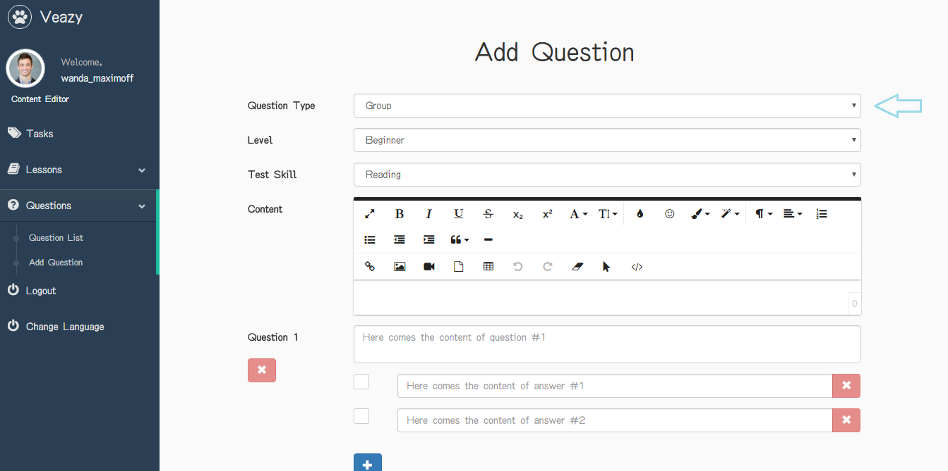

Step 3: User chooses question level in “Level” dropdown list

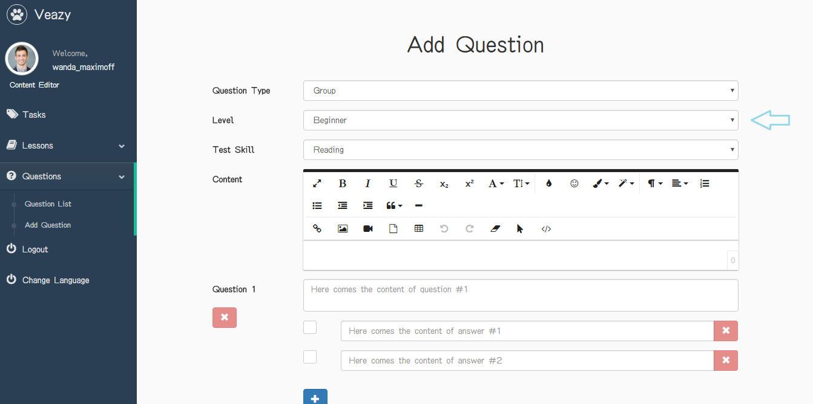

Step 4: User inputs question and answer and choose right answer

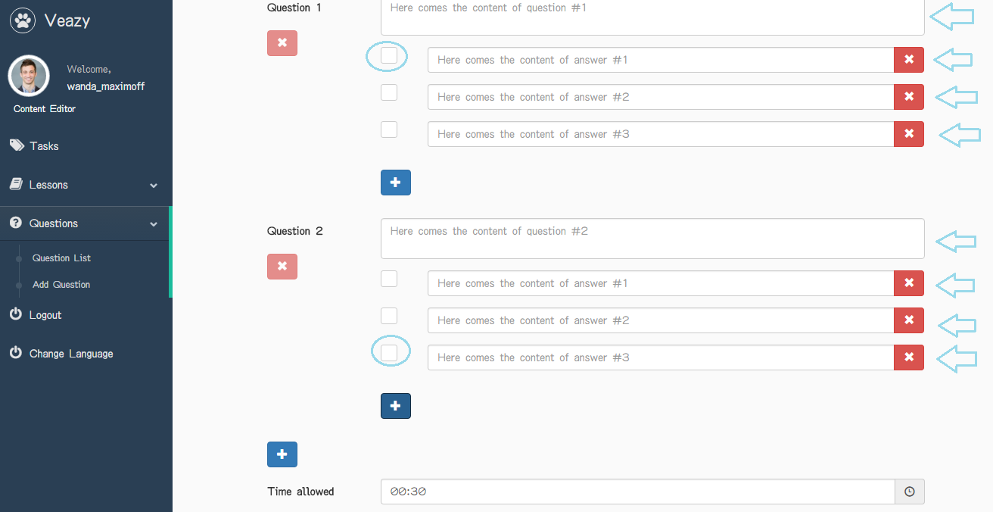

Step 5: User inputs information in section “Content”

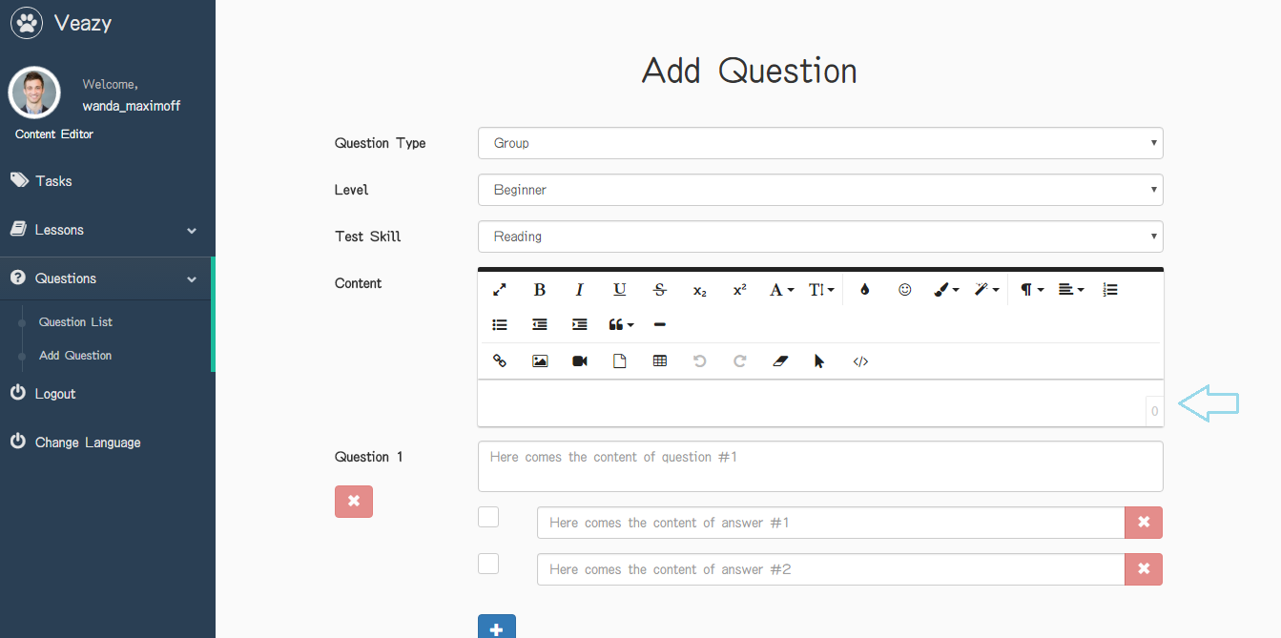

Step 6: User clicks on “+” button under answer field to add more answer

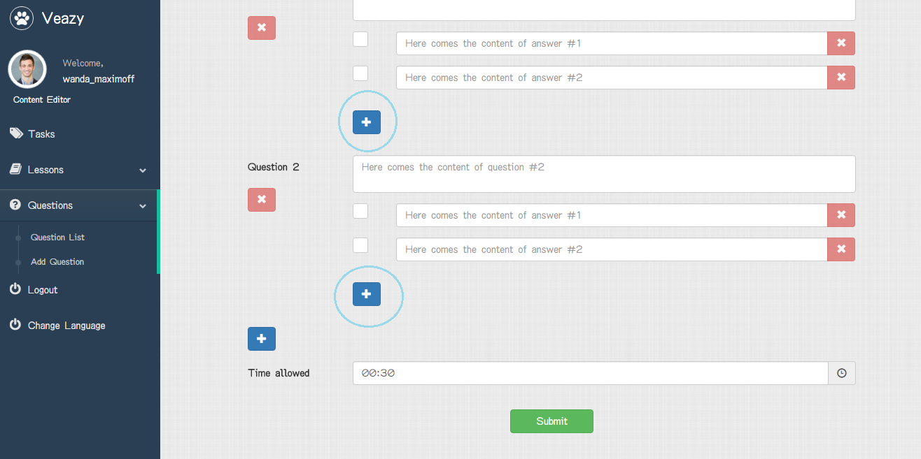

Step 7: User clicks on “+” button under question to add more question

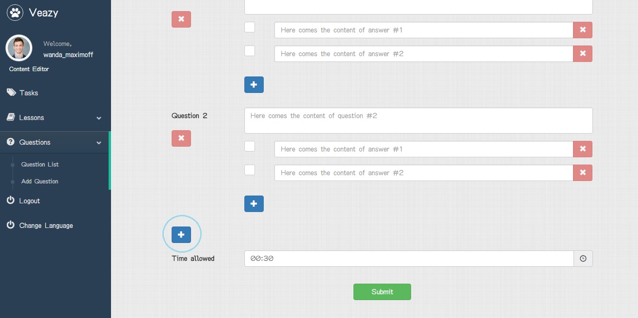

Step 8: Click on “x” button under answer field to delete answer or question

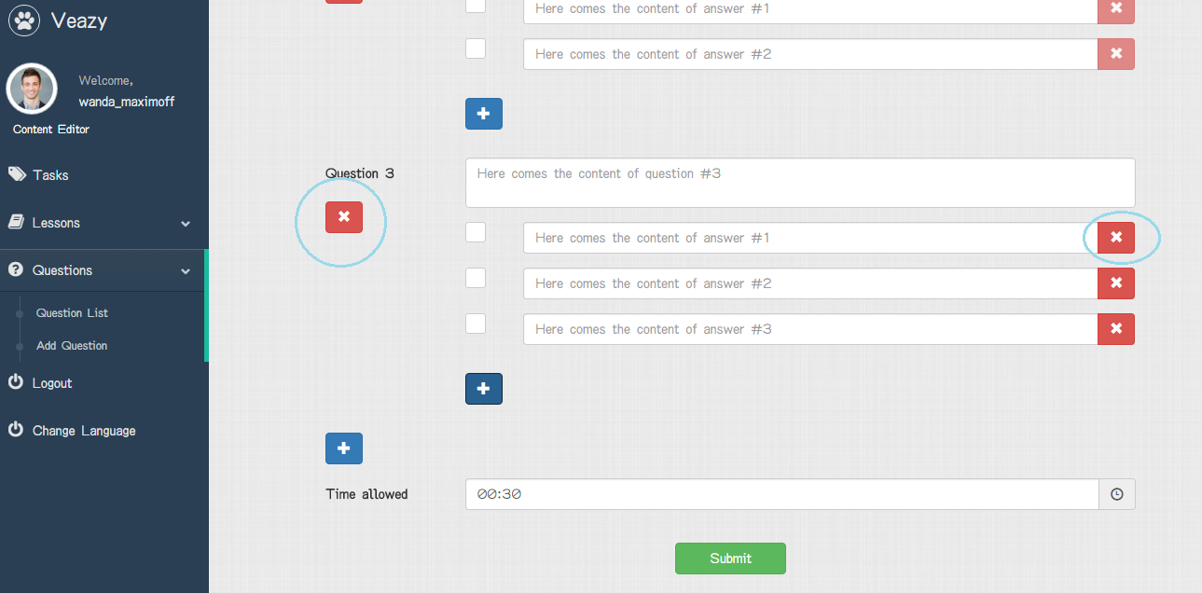

Step 9: User clicks on time icon to select time allowed in section “Time allowed”

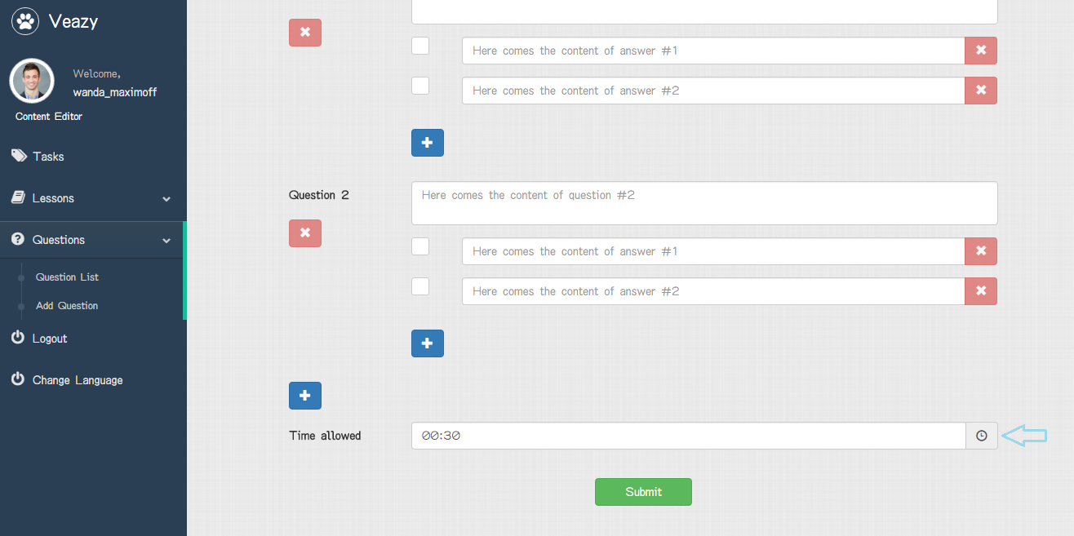

Step 10: User clicks on “Submit” button

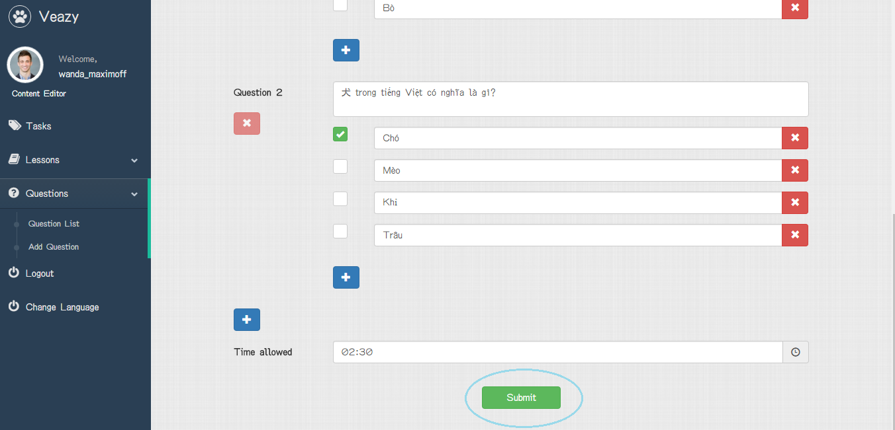

#### Edit Single Question

To edit single question on website, the users do the steps below:

Step 1: User clicks on “Edit” button

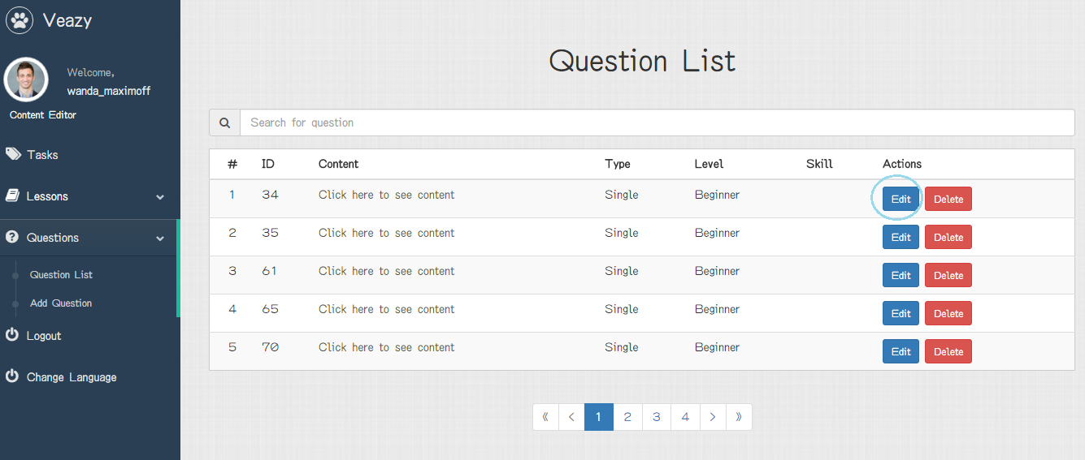

Step 2: User updates question level in “Level” dropdown list

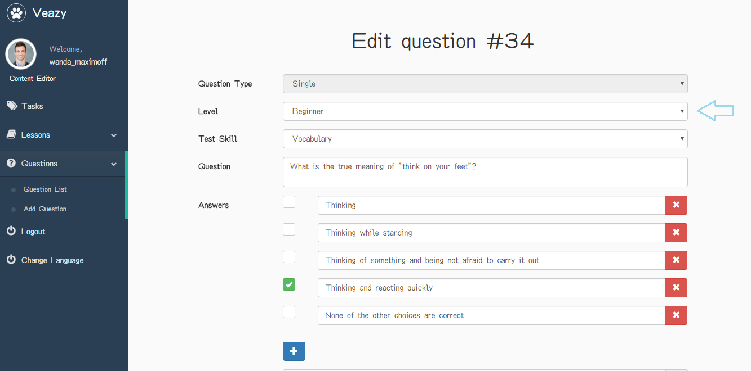

Step 3: User updates question skill in “Test Skill” dropdown list

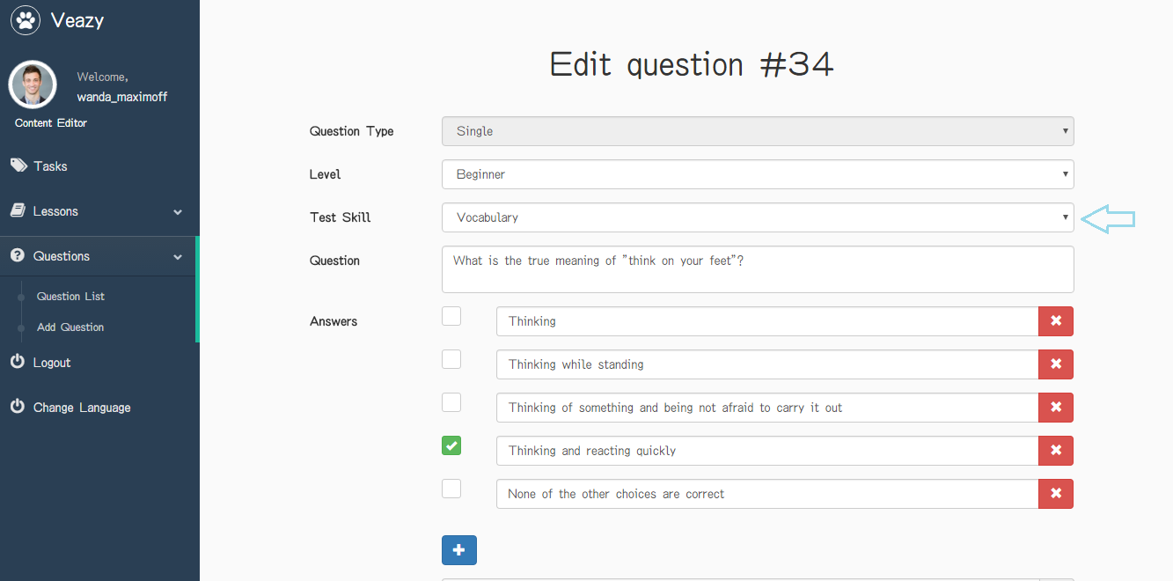

Step 4: User updates information in section “Question” and “Answers” and edits right answer

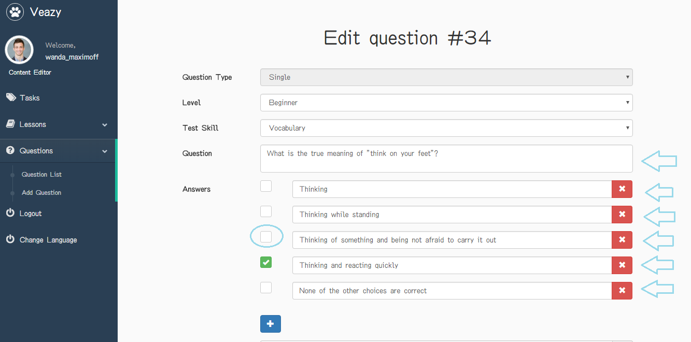

Step 5: User clicks on “+” button under answer field to add more answer

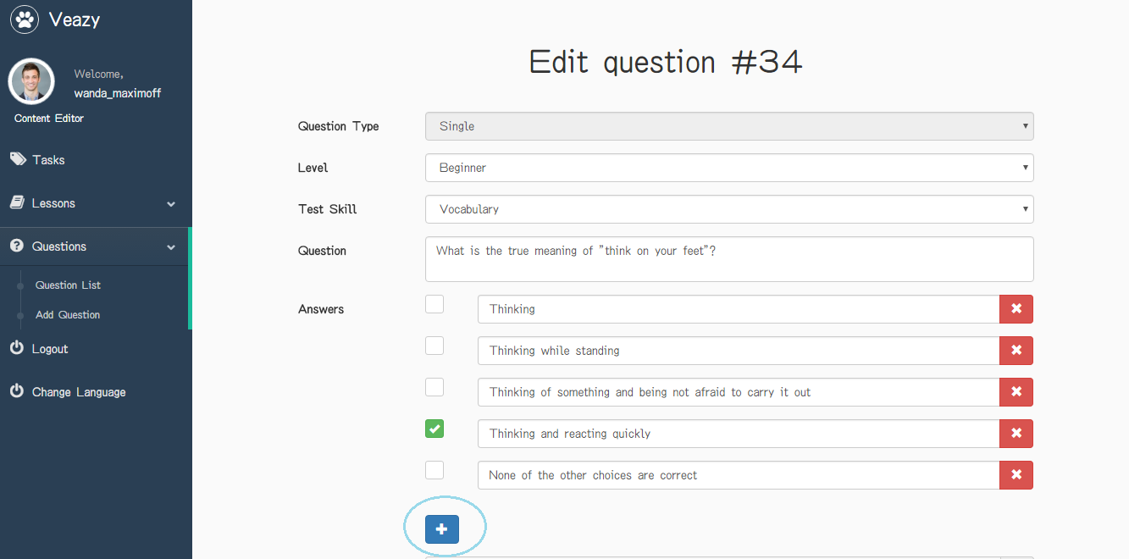

Step 6: User clicks on “x” button under answer field to delete answer

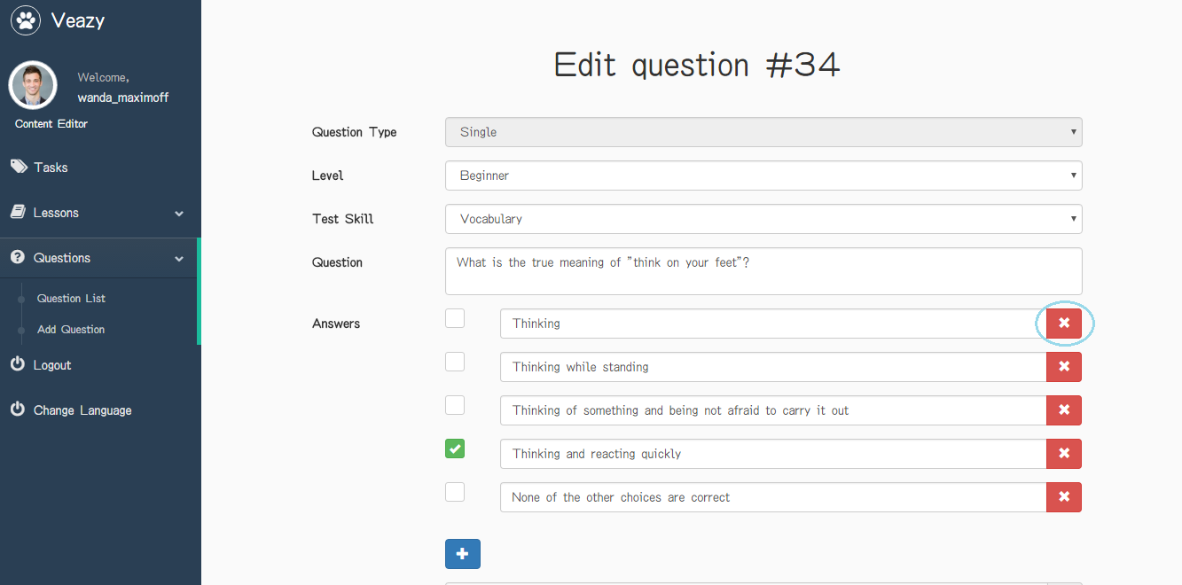

Step 7: User clicks on time icon to update time allowed in section “Time allowed”

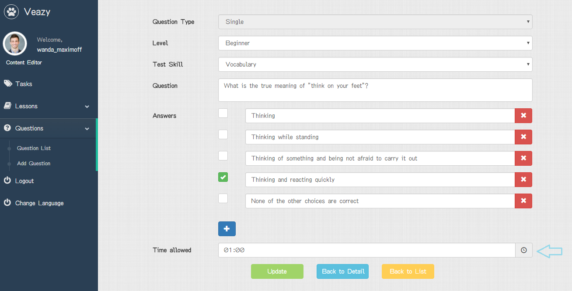

Step 8: User clicks on “Update” button

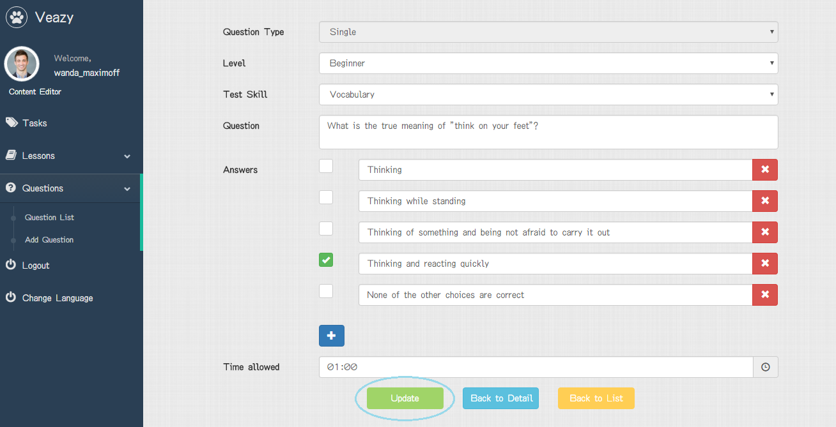

Step 9: System redirects to question list page and edited lesson



#### Edit Question Group

To edit group question on website, the users do the steps below:

Step 1: User clicks on “Edit” button

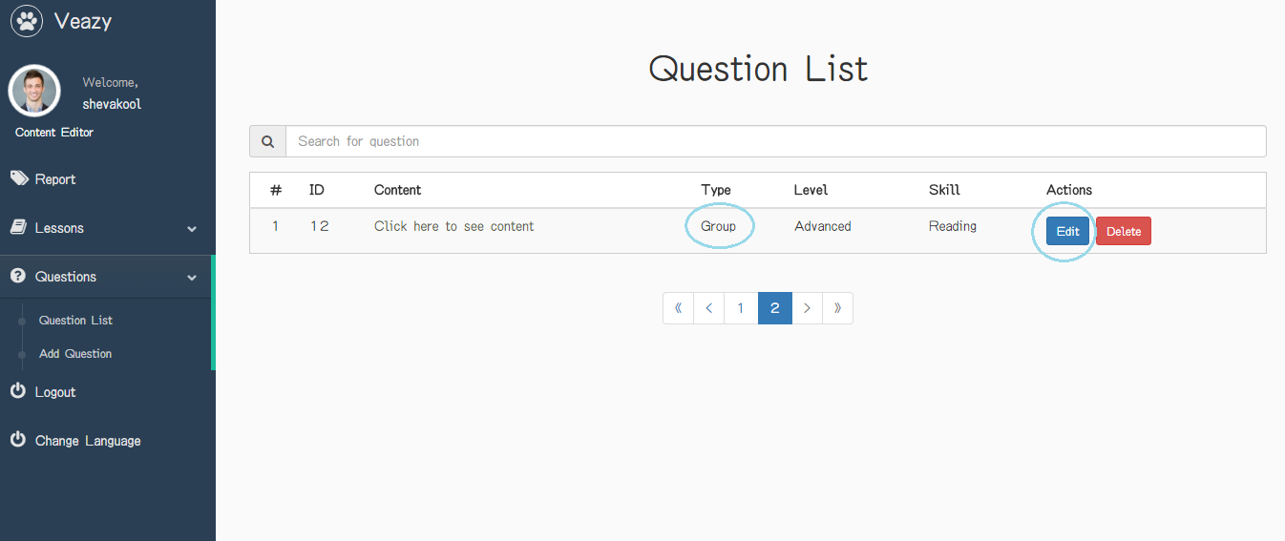

Step 2: User updates question level in “Level” dropdown list

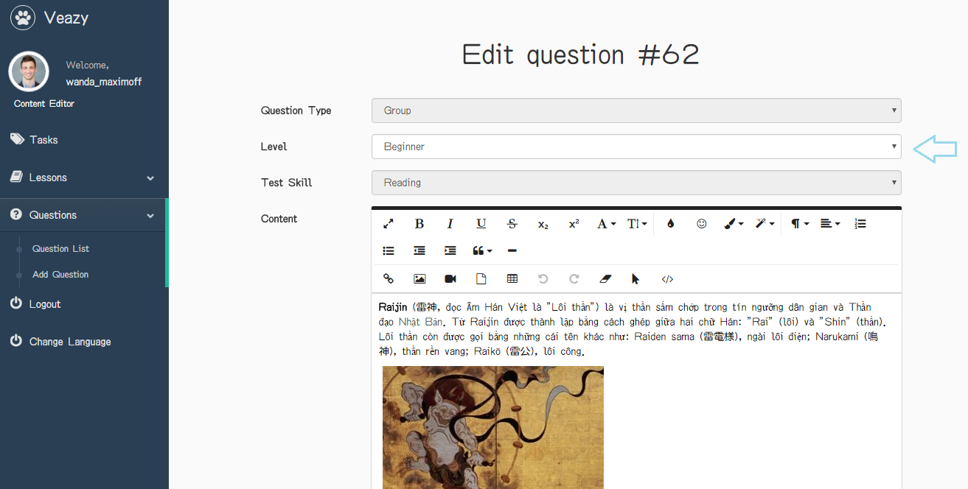

Step 3: User updates information in section “Content”

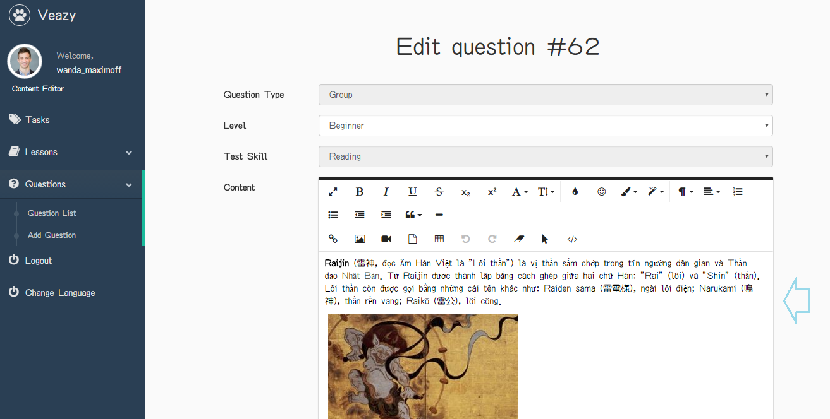

Step 3: User updates information in section “Question” and “Answers” and edits right answer

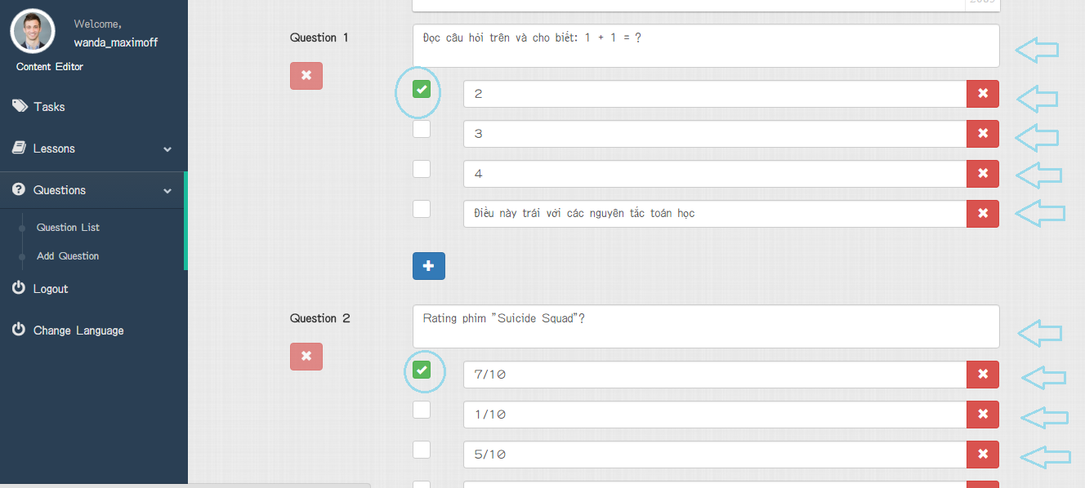

Step 4: User clicks on “+” button under answer field to add more answer

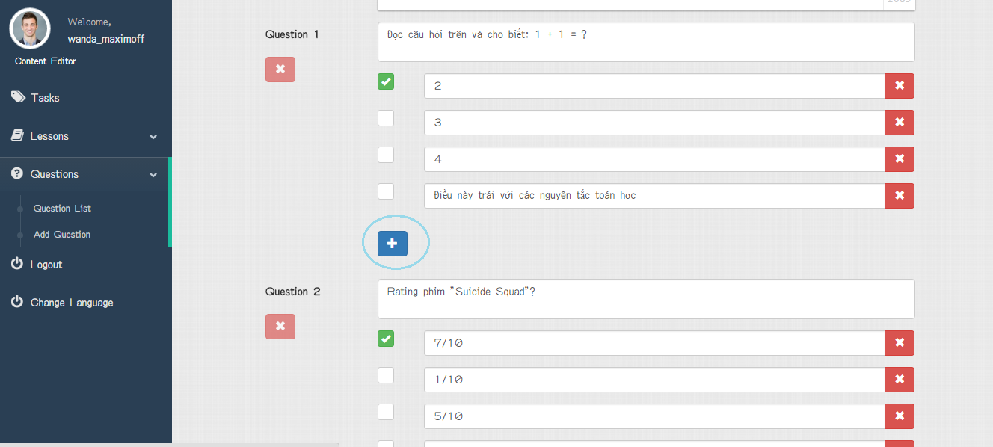

Step 5: User clicks on “x” button under answer field to delete answer or question

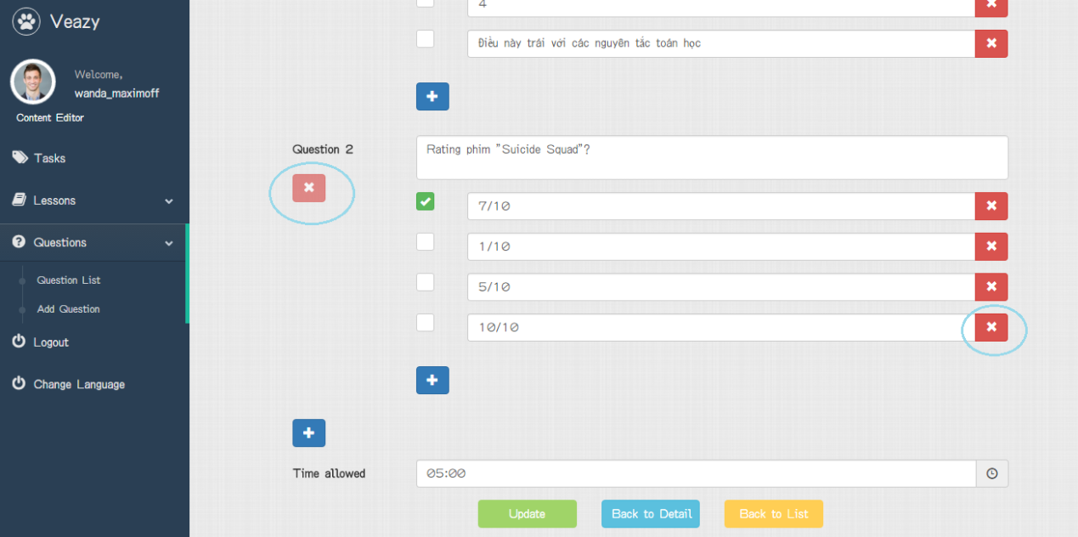

Step 6: User clicks on time icon to update time allowed in section “Time allowed”

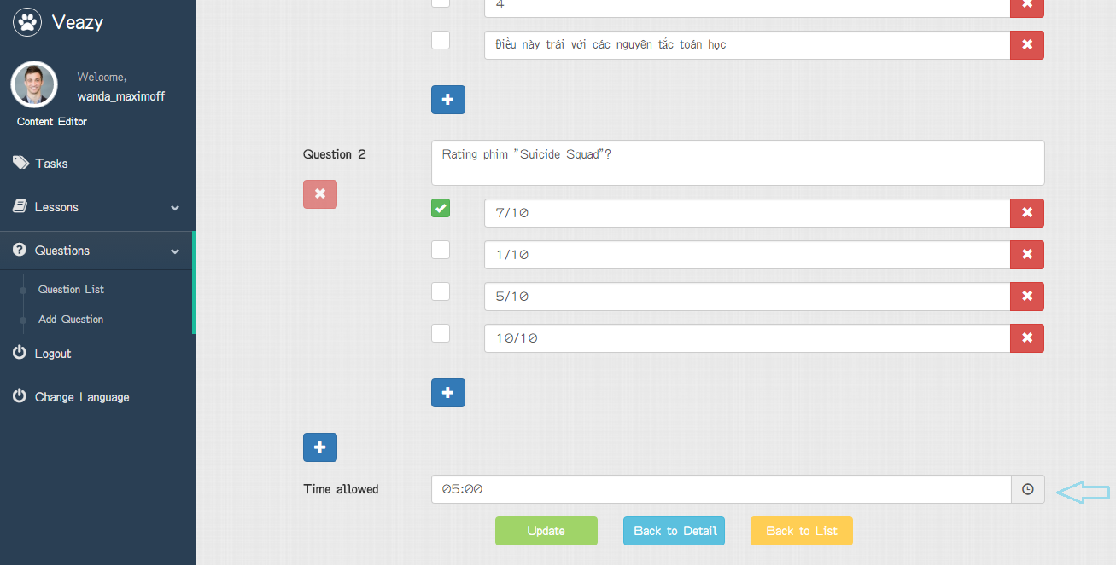

Step 7: User clicks on “Update” button

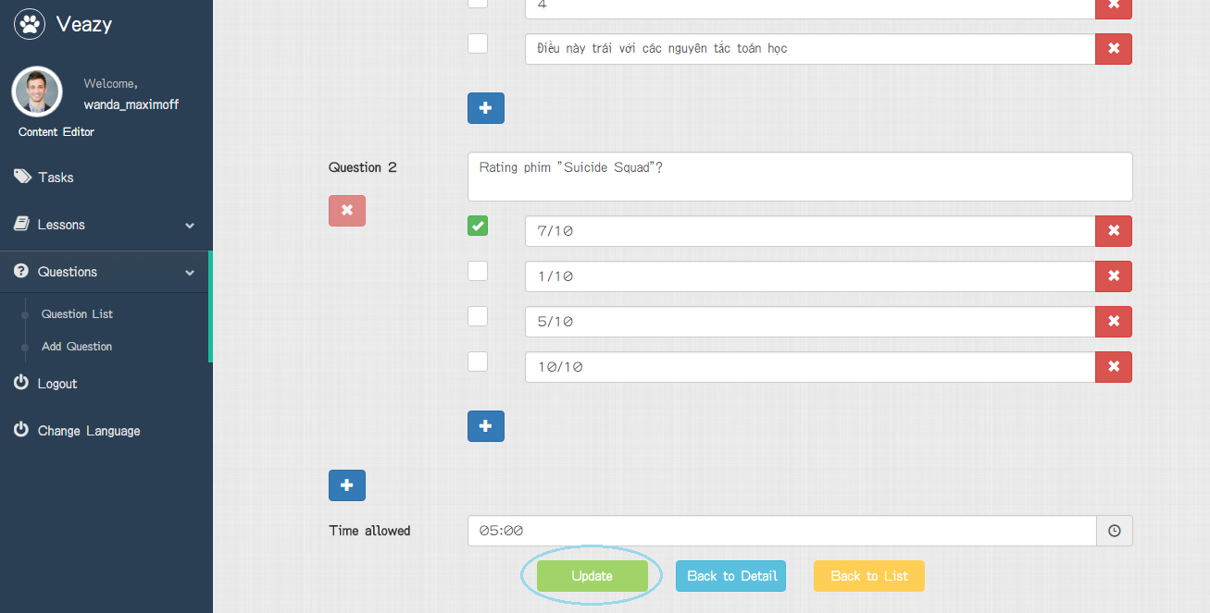

Step 8: redirects to question list page and edited lesson



#### Delete Question

To delete question on website, the users do the steps below:

Step 1: User clicks on “Delete” button in lesson list page

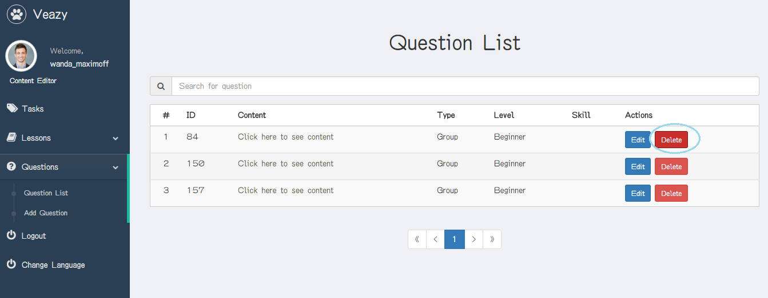

Step 2: User clicks on “Delete” button in “Delete question” popup

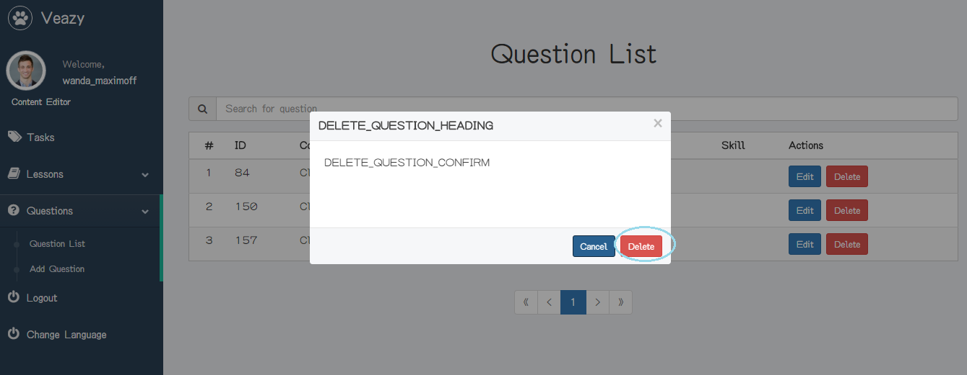

#### View Question Report

To view question report, the users do the steps below:

Step 1: User clicks on “Tasks” link at dashboard in content editor dashboard page



Step 2: System redirects to view report page



#### Search Task

To search task, the users do the steps below:

Step 1: User inputs text to the search box

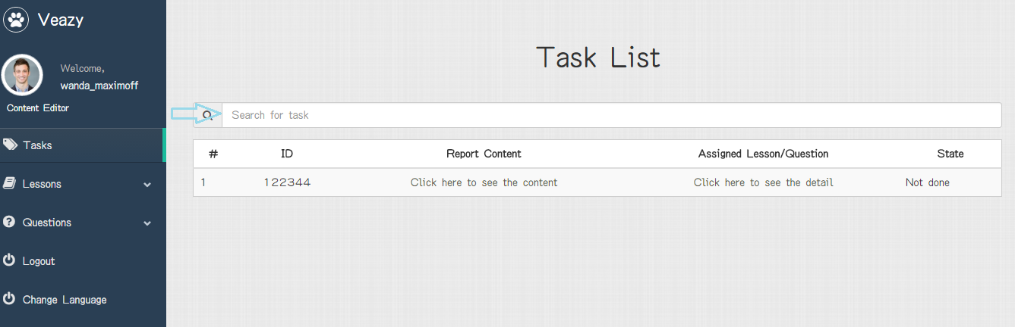

Step 2: User clicks on “Search” button

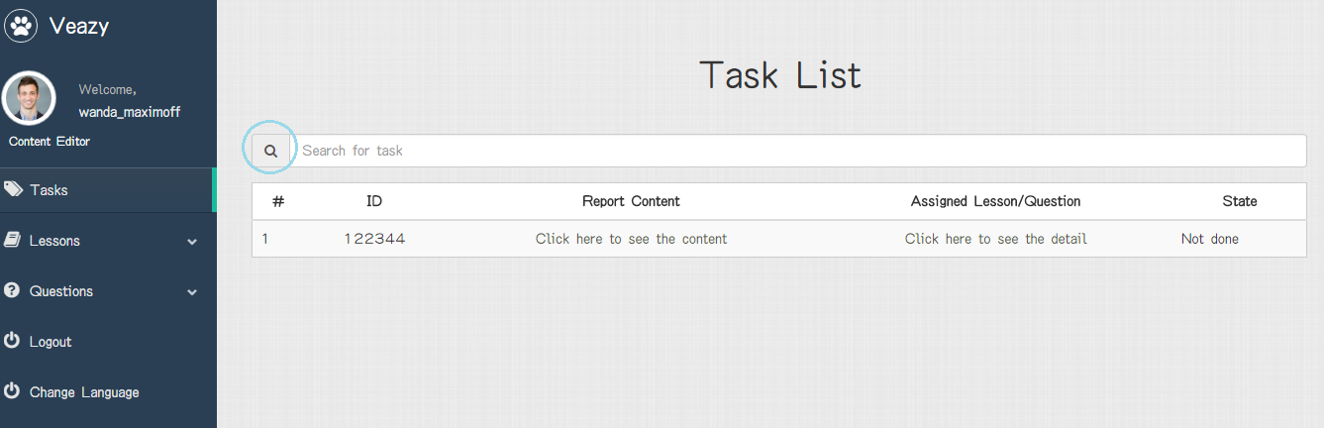

#### Change Language

To change language, the users do the steps below:

Step 1: User clicks on “Change Language” link at dashboard

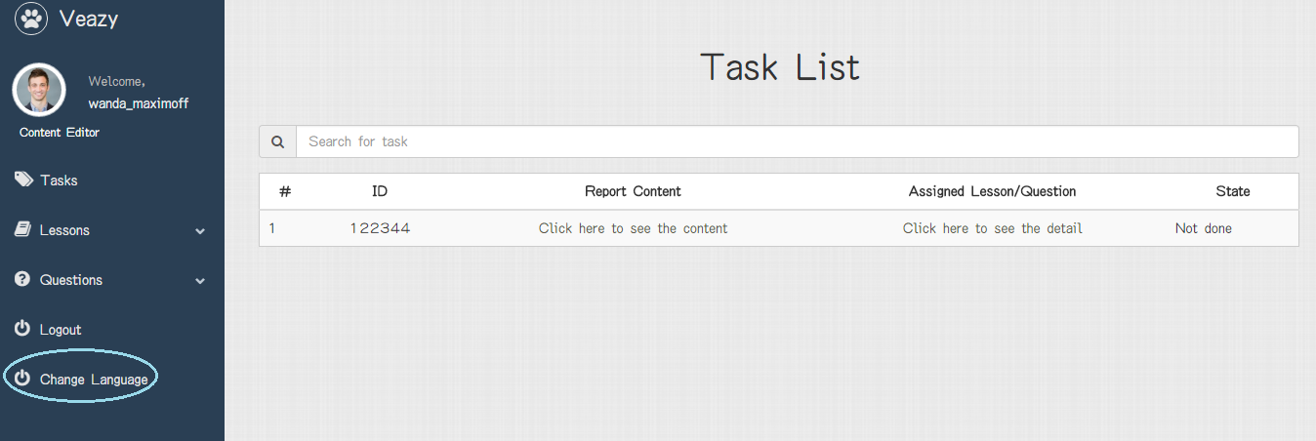

Step 2: System changed language of website

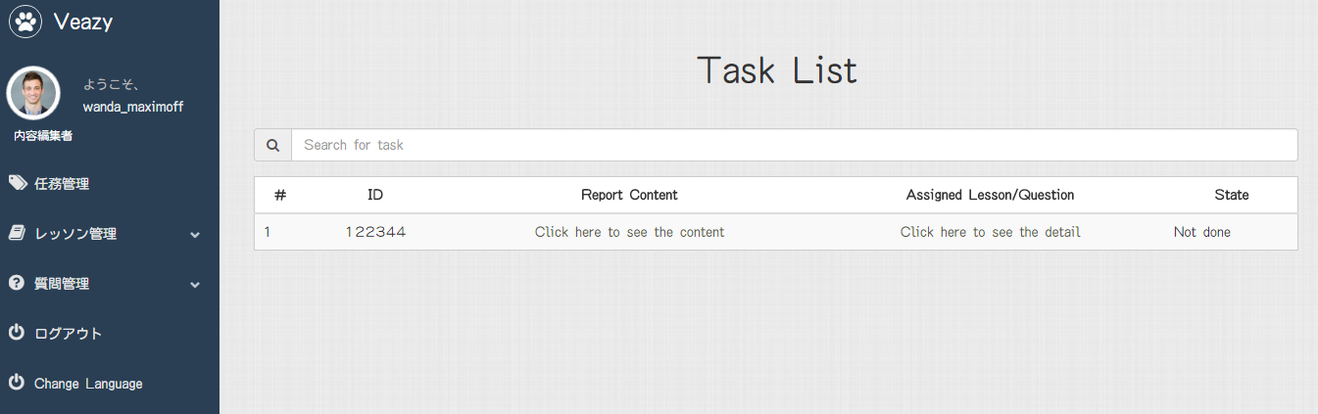

### Administrator

#### Manage Account

##### View Profile

##### Change Password

##### Logout

#### Manage User

##### View User’s List

##### View User Profile

##### Set Role User

##### Ban User

##### Unban User

##### View System Statistics